Why the CAF will never fix its retention problem
  - A rant-become-essay on the chronically dying military denied the bliss of death
By A. Nonymous
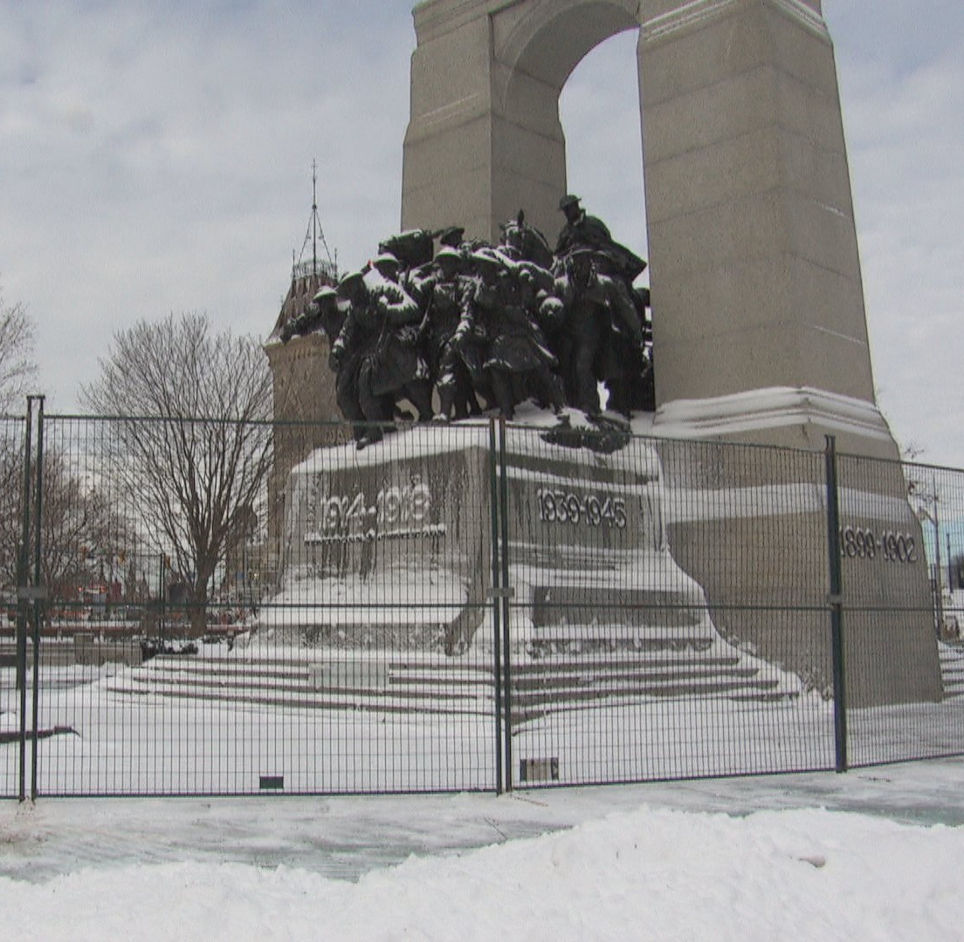

Contents
An introduction to the problem 3
1. The Absolute State of CAF Internal Communications 4
A. The Hardy Boys and the Corporal who didn’t care anymore 7
B. Down the gender-neutral Rabbit Hole 10
Guide on Equity, Diversity and Inclusion Terminology 10
Canada’s anti-racism strategy 11
Ask me anything - Asian heritage month 12
CFB Edmonton pride parade 2022 13
Redefining Chaplaincy 15
Redefining the CAF Dress Regulations 17
C. A note about White supremacy 19
2. Faith in the Chain of Command 20
A. We need to talk about the jabs… 21
Sergeant Kipling and the anthrax vaccine 23
Informed consent 25
B. Fear and Loathing at the Royal Military College 27
3. Don’t cry because it’s over, smile because it happened! 29
A. Grandpa’s car 29
B. The mission of the CAF 30
Defending the country 31
Defending Canadian Values 32
C. The CAF After 1945 37
Cold War Canada: Or, how I learned to stop worrying and love the US Military 37
Gorbachev, burgers, and the end of USSR 38
Afghanistan: Why are we here? How do we leave? 38
Back full circle 39
The Check Engine Light is on, but nobody is home 40
All Good Things Come To An End 43

An introduction to the problem
The Canadian Armed Forces, hereafter referred to as the CAF, has a serious retention problem. Any organization with such a problem will feel the sting, but the CAF has a particularly nasty disadvantage that corporate entities don’t, that being the mandate to provide training to its members. When a person joins, the CAF is obligated to provide necessary training to them, either directly or through outsourcing (with some exceptions). This means that, when a person chooses to leave before retirement eligibility, they are bringing with them the CAF’s investment, and imposing the requirement for a reinvestment in whoever replaces them. In addition to the financial cost, there is the cost of time. Training takes time. An officer who goes through the Regular Officer Training Program will cost the CAF about 4 years of time just to get their degree, sometimes up to 6. Then, they must complete military occupational training, which might take an additional year or more. NCM training works a bit differently, as it includes stages of qualification in many cases. Due to that, achieving the final stages of qualification can take a similar amount of time for the most technical NCM trades. To further compound the problem, those running the military training are being taken from positions where they would otherwise be doing the jobs they are qualified for; fewer people to run training means a longer wait to fill positions, whereas maxing out training capacity would emaciate operational positions.
Why are people leaving though? The pay isn’t bad, though certain postings have a severe cost of living problem that hasn’t been addressed. The work conditions vary, but aren’t horrendous most of the time. As mentioned above, the opportunities for free (did I mention FREE?) training are quite numerous. Seriously, you can get a free master’s degree paid for.
As mentioned, the cost-of-living problem is dire in some regions. I won’t go into too much detail, but Ottawa (as an example) is the region with the most military people (around 10,000) and it is prohibitively expensive to live there. The CAF has chosen to do nothing about the problem, so many are choosing to release rather than live in poverty upon receiving a posting there. But Ottawa is not the entire country, contrary to the beliefs of those who live there. Costs aren’t that bad in places like Edmonton, Medicine Hat, Gagetown, Cold Lake. They are manageable, and it is possible that the CAF will address this issue in the coming centuries. Cost of living doesn’t explain the whole equation.
Why else might people choose to leave? Do they perceive the CAF as an organization which supports their personal values? Likely not. The CAF is downstream from its boss, the federal government. Therefore, if the feds adopt a new way of thinking, the CAF will eventually fall victim to mandate it as well. This is the most significant problem. Cost of living, training deficits, pay, benefits, all of these can be addressed if the leadership so chooses. The toxic dictates of the federal regime, however, cannot; The CAF is helpless to resist orders from its boss. This is the root problem. At the very least, it is the most significant problem, although less direct than cost of living might be. The point of no return on this issue is also firmly in the past, and unlike the CAF, I will be addressing the issue going forward in the paper.

The Absolute State of CAF Internal Communications
If only you knew how bad things really are…
- Anonymous 4chan poster
Every week, mass emails are sent to every CAF member and DND civilian on their internal email system, and they are a good dip stick of what the top brass (tin, because we’re broke) care about. They are called defense team messages, and they have anywhere from 10-25 headlines/links within. I acquired a set of these messages sent from January to June of 2022 and made the below list of headlines which I thought were telling (keep in mind these are merely an excerpt of each email). Take a look and see if there is anything you notice about these (aside from spelling mistakes and encoding errors), noting there are some duplicates that were used in multiple weekly messages:
List of noted headlines in Defence Team Messages, 01 Jan to 07 Jun 2022 | Date
Mangers: Complete the Questionnaire on the Use of Indigenous Languages | 11-Jan
The Multicultural Calendar 2022 is now online! | 11-Jan
nil | 18-Jan
Ask Me Anything: Black History Month | 25-Jan
Black History Month: Design Jams in February 2022! | 25-Jan
Additional LGBTQ2+ Mentorship session | 25-Jan
Black History Month 2022: Celebrating Black History Today and Every Day | 01-Feb
Black History Month: Design Jams in February 2022! | 01-Feb
Implementation of the Pay Equity Act | 01-Feb
Ask Me Anything: Black History Month | 08-Feb
Public Service Pride Network Winter Update | 08-Feb
The Canadian Armed Forces modernizes military ranks in French | 08-Feb
Check out the upcoming webinar, “Understanding Microaggressions – The Mental Health Connection” | 15-Feb
The Canadian Armed Forces modernizes military ranks in French | 15-Feb
Public Service Pride (PSP) Welcomes New LGBTQ2+ Executive Network! | 15-Feb
Join the Defence Team Black Employees Network in celebrating Black History Month | 22-Feb
60 seconds with Seyi Okuribido-Malcolm, Director of the Anti-Racism Secretariat | 22-Feb
Ask Me Anything: International Women’s Day - A Courageous Conversation with Women in STEM | 01-Mar
Join the Defence Champion for Women for the Defence Team national event celebrating International Women’s Day | 01-Mar
Attend IM Group Women in STEM’s panel discussion: Sharing Our Journey | 01-Mar
To celebrate International Women’s Day, the National Defence Stakeholder Engagement Office invites you, on March 8th, to attend a Webinar | 01-Mar
International Day for the Elimination of Racial Discrimination: Opportunities for Action | 01-Mar
International Women’s Day 2022 Joint Leadership Message | 08-Mar
Video Message from the Interim Clerk | 08-Mar
Women Supporting Women at Canadian Forces Health Services | 08-Mar
International Women’s Day: Women's Leadership | 08-Mar
Getting Reel: Happy IWD! | 08-Mar
Mentorship is key for CPO1 Nancy Lachance | 08-Mar
SSC’s Indigenous Peoples Circle presents: Keynote presentation with Mohawk Olympian and Activist, Waneek Horn-Miller | 08-Mar
Call for nominations: Government of Canada 2022 Public Service Pride Awards | 15-Mar
International Day for the Elimination of Racial Discrimination: Opportunities for Action | 15-Mar
Pay Equity Act Implementation Update and Next Steps | 23-Mar
Getting Reel: International Day for the Elimination of Racial Discrimination | 23-Mar
International Women’s Day 2022: Women inspire women at sea | 29-Mar
Message to Defence Team members: Promoting and measuring inclusive behaviours within the Defence Team | 05-Apr
Building a more inclusive Defence Team culture | 05-Apr
Ask Me Anything: Sikh Heritage Month | 05-Apr
Defence Team News Interview: Exercise BREAKTHEBIAS with Captain Jan-Marie Gill and Cpl Natasha Schroeder | 05-Apr
Department of National Defence and Canadian Armed Forces provide update on culture change efforts and military justice system reform | 05-Apr
Become an Ally of the LGBTQ2+ Communities - Webinar April 14th at noon EDT | 12-Apr
Ask Me Anything: Sikh Heritage Month | 12-Apr
Officers Must Play Key Role in Transforming Organizational Culture | 12-Apr
Gender Inclusivity in the Canadian Armed Forces: The Role of the Chief Petty Officer Second Class/Master Warrant Officer | 12-Apr
Building a more inclusive Defence Team culture | 19-Apr
Share your experience virtually for the tenth annual Gender-based Analysis Plus (GBA Plus) Awareness Week | 19-Apr
Combatting Hate / Combattre la haine | 26-Apr
Important Read: The Ministerial Advisory Panel report as part of the effort to eliminate systemic racism and discrimination in the Defence Team | 27-Apr
How you can help build a more inclusive Defence Team culture | 27-Apr
Ministerial Advisory Panel report released as part of effort to eliminate systemic racism and discrimination on the Defence Team | 27-Apr
Asian Heritage Month 2022: Celebrating innovation and perseverance | 27-Apr
Celebrate Asian Heritage Month: A message from the Defence Champion for Visible Minorities | 27-Apr
Celebrate Asian Heritage Month: A message from the Defence Champion for Visible Minorities | 03-May
Asian Heritage Month 2022: Celebrating innovation and perseverance | 03-May
Ask Me Anything - Asian Heritage Month: A courageous conversation on disrupting invisibility | 10-May
Gender-Based Analysis Plus Awareness Week 2022 | 10-May
Gender-Based Analysis Plus Awareness Week Event: GBA Plus in action in the Defence Team | 10-May
Getting Reel: It’s GBA Plus Awareness Week! | 10-May
Jocelyne Bourgon Visiting Scholar Lecture: The time is now for black Canadians in the public service | 10-May
Message from the VCDS: An important milestone in the Victims?Rights and Summary Hearing Implementation / Message de la VCEMD : un jalon important relativement ?la mise en 渦vre des droits des victimes et des audiences sommaires | 11-May
Watch the Defence Team panel discussion: Addressing racial inequities | 17-May
Message from the Champion for LGBTQ2+ Communities on the International Day against Homophobia, Transphobia and Biphobia | 17-May
Message from the VCDS: An important milestone in the Victims’ Rights and Summary Hearing Implementation | 17-May
Invitation from the VCDS to participate in the 2022 Run for Women | 17-May
A conversation with Captain Sarabjot Anand on Asian Heritage Month | 17-May
New Ombudsman report investigates employment equity in the DND and CAF | 17-May
Jocelyne Bourgon Visiting Scholar Lecture: The time is now for black Canadians in the public service | 17-May
Message from the MND: Raise Your Voice Forum / Message de la MDN : Forum Faites-vous entendre | 19-May
New Ombudsman report investigates employment equity in the DND and CAF | 24-May
The Guide on Equity, Diversity and Inclusion Terminology | 24-May
Defence Team hiring managers: Student hiring and Indigenous Awareness Week! | 24-May
Acting Commander Canadian Army marks Indigenous Awareness Week | 24-May
International Decade of Indigenous Languages: Gikinoo'amaadiwinan (Learning from Each Other) | 24-May
Madame Arbour’s Final Report Released: What does it mean for the Defence Team? | 07-Jun
Champion’s message – Pride Season 2022 | 07-Jun
Attend IM Group Women in STEM’s panel discussion: Sharing Our Journey | 07-Jun
National Indigenous History Month | 07-Jun
Strengthening Relationships with Indigenous Peoples Through the Consultation and Accommodation Process | 07-Jun

Women. Diversity. Inclusion. Pride. LGBTABCD0123. Indigenous. Asian. Gender. Victims. Hate speech. Racism. Anti-racism. Discrimination. Blacks. Microaggressions. Multiculturalism.

The Hardy Boys and the Corporal who didn’t care anymore
For a military organization, there sure is a lot of time and space devoted to counter-productive bullshit. Yes, it’s bullshit and I’m tired of pretending otherwise. These emails do have some worthwhile or at least non-bullshit material most of the time, usually right near the bottom of the message, but it is drowned out by the aforementioned nonsense. Below is a (poorly done) screenshot of one such Defence Team Message, broken into 2 pieces. Pretend you are a corporal who just received this in their inbox. That’s a joke by the way, I’d imagine most corporals have these set to auto-delete on receipt…

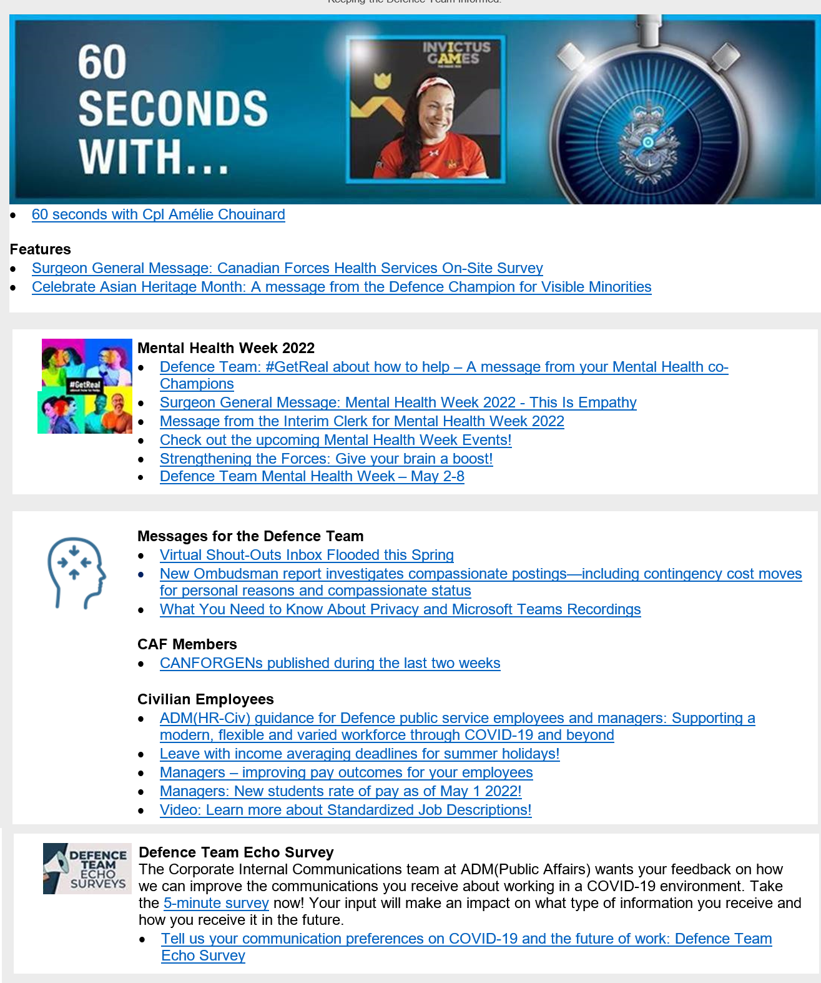

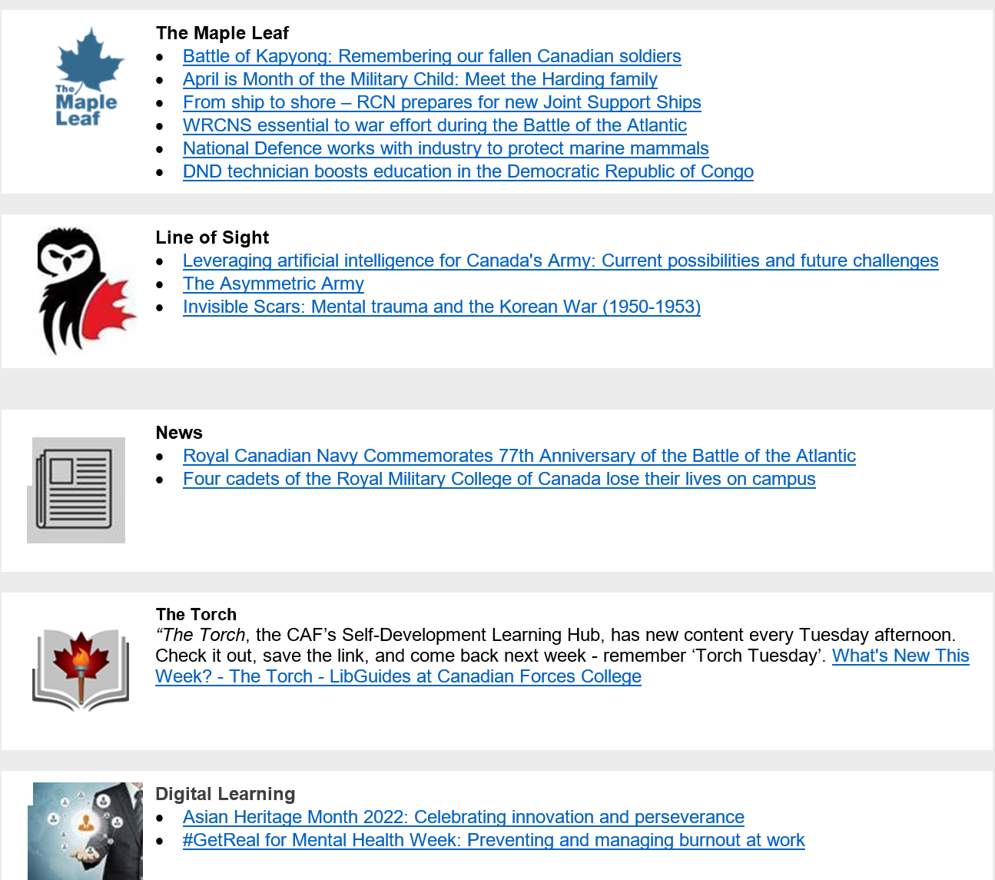

I’d imagine it went something like this. You saw the 60 Seconds with XYZ, and figured you could use those 60 seconds for something else. Or maybe not, fair enough. Then you saw the health services survey, and likely decided to politely, but firmly decline. Finally, you saw Asian heritage month and closed the email. Already on the 3rd heading, they’re virtue signaling with race-based propaganda, so why bother reading more? That’s unfortunate, because way down near the bottom of the message, there was a link talking about how four military members lost their lives in a motor vehicle accident. Would you consider that event to be, perhaps, of more importance than coronavirus bullshit or pay outcomes for civilian employees? Well, you considered wrong in the eyes of the author.
Referencing the list of headings above, do you see how people would get tired of such nonsense very quickly, even those who are unaware of the nature of this diversity stuff? Fortunately, those headlines are mostly from the weekly messages. That’s right, they also send topic specific messages when pertinent. As you can well imagine, most of these topics can fit within the women-gender-nonwhite-LGBTABCD-racism sphere of conversation.
You, the imaginary corporal, would be forgiven for thinking that the CAF exists solely to convert money into pride flags and women-only events. Imagine closing one of these emails, then looking outside the window at a parking lot full of dead-but-alive military scrap vehicles. What sort of organizational priorities do you perceive at this point? Statistically, as an imaginary corporal, you are most likely 25-30 years old, male, White, and heterosexual. Based on the firehose of bullshit in your inbox every week, it would be somewhat clear to you that unlike the CAF’s email servers you are neither wanted nor appreciated, and you would understand that the CAF cares more about dividing its people into categories than it does leveraging them to accomplish its mandate in unison, whatever that mandate has become. Isn’t the point of the uniform to make everyone the same? Didn’t you learn in public school that race doesn’t matter, and that a person is to be judged by their merits, rather than their skin or genitals?

Down the gender-neutral Rabbit Hole
These are just emails, of course, but they are backed up by a variety of CAF and government sources and corroborated by real life events. Let’s check out a few, shall we?

Guide on Equity, Diversity and Inclusion Terminology
https://www.noslangues-ourlanguages.gc.ca/en/publications/equite-diversite-inclusion-equity-diversity-inclusion-eng (source: Defence Team Messages)
I recommend taking a look at this, a government dictionary of diversity stuff. Here is an excerpt from a heading for ‘race’:
“Definition: A group of people who are arbitrarily categorized according to common physical characteristics, regardless of language, culture or nationality.
Notes: The concept of race has long since been used to establish differences between groups of people, often according to a hierarchy. It focuses on identifiable physical characteristics, such as skin colour, hair texture and facial features.
There is no scientific basis for the concept of race.
Refusing to talk about race could imply that racism and its consequences do not exist.”
Wait, WHAT? Race doesn’t scientifically exist (false), but refusing to talk about it [the thing that doesn’t exist] could imply that racism and its consequences do not exist? This reads like an awful facebook-tier meme from grandma, but this is an official government website. If you check the second definition for ‘racism’ (they have two) it states that it is ‘An ideology that establishes a hierarchy between races or ethnic groups’. An ideology that establishes hierarchy between different types of things that don’t exist? Anyways, please take a look and suffer on your own time, my brain already hurts; Clearly, I am not cut out for elite mental gymnastics.

Canada’s anti-racism strategy
https://www.canada.ca/en/canadian-heritage/campaigns/anti-racism-engagement/what-we-heard.html#a2 (Source: Defence Team Messages)
Remember how race was defined as a social construct that doesn’t exist scientifically, just moments ago? Aside from the fact that the assertion is ludicrous, it is also scientifically false; Trusting the science© just isn’t the same since Thalidomide was deemed safe and effective™. This fake definition comes up as the first definition in the glossary, even before the introduction. “Race isn’t real, now read 70+ pages about how we’re going to address discrimination based on something that isn’t real” I’m not going to rehash this, let’s jump to the introduction and see what lovely morsels they have for us. I’m going to paraphrase some:
-foreign born non-Whites earn less than foreign born Whites
-Black men earn less than White men
-Natives are 4.9% of the population but 23.1% of criminal offenders
-There were 2,073 police-reported hate crimes in Canada in 2017 – a 47% increase over the previous year
-Hate crimes targeting Jewish and Muslim populations were the most common type of hate crime related to religion
-11% of individuals with a non-Christian religion indicated that they faced discrimination based on their religion in the previous five years compared to 1% of Christians.
The first two can be thrown out immediately. It is illegal to discriminate against people in Canada based on race, unless they are White. Earnings gap is therefore a personal choice, nothing more. The third one is complicated, and you can interpret it however you want. Are Natives more prone to criminal activity? Are their living conditions worse? Too bad, they have the choice to move out and work for a living, just like everyone else.
Hate crimes, eh? Hate crimes against non-Whites are easy to flaunt when hate crimes against Whites aren’t even considered hate crimes! Don’t believe me? Here, check out this article:
https://www.washingtonpost.com/news/worldviews/wp/2016/07/07/canadian-judge-punching-a-caucasian-and-yelling-i-hate-white-people-isnt-a-hate-crime/
Likewise, this applies to religions as well. Remember those church vandalism incidents during the summer of 2021, in the wake of the mass child grave that still hasn’t been proven to exist? Remember how the RCMP diligently investigated them? Yeah, uh, they didn’t do shit because Christianity bad, or something. Meanwhile, Rabbi Shekelberg paints a swastika on the Synagogue at night, and the pity points roll in.
The conclusions of this anti-racism strategy are entirely predictable: In order to stop racism, they will indefinitely look for racism. Because they have a financial interest in finding racism, they will continue to discover racism, even if it is invented.

Ask me anything - Asian heritage month
https://www.canada.ca/en/department-national-defence/maple-leaf/defence/2022/05/ask-anything-asian-heritage-month.html (Source: Defence Team Messages)
May is Asian heritage month, a time to celebrate the contributions of Asians. That’s fine, I guess. No, you don’t get to have a White heritage month because of reasons; go fuck yourself. So, what will this event consist of? The description is, uhhhh, helpful I guess?
“The Ask Me Anything series provides you with an opportunity to increase your perspective—to learn from the lived experiences of individuals who are bravely sharing their stories to help educate and move the public service towards a culture where equity is embedded.”
Good for them, except what are they talking about? Lived experiences, does that imply that the mayonnaise coloured among us have neither lived, nor experienced anything? Bravely sharing what stories? Educating us towards equity? I could go on a tirade about equity. In fact I will later, but I will try to focus for the moment. This description is awful, forget what I said earlier, and forget the description altogether; It doesn’t matter, we all know what this is about. Let’s see who the panelists are:
-Alfonso Ralph Mendoza Manalo, Equity, Diversity, and Inclusion Policy Advisor, Race-based Data Collection Policy Advisor, Royal Canadian Mounted Police (RCMP)
-Marilou Moles, Senior Advisor, Integrated Planning and Coordination in the Afghanistan sector, Immigration, Refugees and Citizenship Canada (IRCC)
-Jennifer Hong, Co-chair of Visible Minority Advisory Council (VMAC), Natural Resources Canada (NRCan)
The first and last ones are self-explanatory. Their jobs are to find things to blame White people for. They don’t do actual work, they don’t lift sandbags, or clean halls. They don’t analyze business data for cost effectiveness, nor do they drive tractors. Their jobs are to bitch about racism, blame [White] people for it, and make the organization change at their whim. They have a financial incentive to find (invent) racism. Imagine a sewer treatment plant that just recirculates the same turds to justify its existence. In fact, Alfonso appears to also work to the end of obfuscating or altering police data [race-based data collection advisor] to presumably hide 13-do-50 or similarly inconvenient truths.
What does Marilou do, then? She, uhhhh, runs a lifestyle and fashion blog which “…she uses to support local businesses, showcases Black, Indigenous, and People of Color-owned businesses/artists.” Here it is: https://www.twentyyork.com/marilou-moles
So, we have two race-baiters, and one lady who apparently runs a successful blog. What does this have to do with Asian heritage month again? The authors have gone out of their way to talk about how Asian and diverse and Asian and non-White and Asian they are, and how their Asianness showcases Asian heritage month (for Asians), but have they actually showcased the merits of Asia or their own personal merits? Maybe they have, but it certainly isn’t mentioned here. This is the problem; nobody should care objectively that they are Asian in this context. Are they diligent and good people who contribute positively? Nobody objectively cares where a desk fan is made until it demonstrates its ability to move air. Frankly, this is an insult to Asia and its people. I know a variety of Asians, of varying types. None of their cultures consist of bitching about racism and blaming whitey for everything, though you would be forgiven for assuming that after seeing this abomination. Granted, I didn’t attend the virtual event, so my ability to pass judgement is limited, but I hardly think that my judgements of the invitation are far from the truth.

CFB Edmonton pride parade 2022
(Source: CFB Edmonton Pride Parade Op Order)
The gays just want to get married, bigot. What they do in the privacy of their own home is none of your business.
-Someone, somewhere, a long time ago, in a galaxy not that far away
Ah, 2004! What a good year it was. Windows XP was changing the face of the personal computer, and Half-Life 2 had just debuted. The SUV and the McMansion were still iconic, and the drunken feel-good of the 90s had not yet become a hangover. The gays were allowed to get married in several Canadian provinces, and were a year away from federal recognition. Finally, they would get what they wanted, then join society as equals, and everyone would live happily ever after…
But that was 18 years ago. Has such a future come to fruition?
How it started VS How it’s going
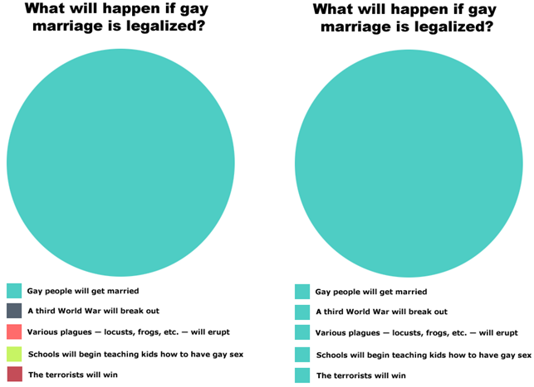
Well, I wouldn’t continue writing if it had; Please refer to the above image.
It turns out that the legal recognition of gay marriage wasn’t enough for them. No, sir. They require businesses to bake gay cakes for them, against the faith of the owners. They need taxpayer subsidized gay parades in every major city, to showcase how proud they are of being gay. They need gay representation in businesses, and they need businesses to have gay flags and rainbow logos for gay month (June). Gay month? Not enough. They need gay season, which now exists all summer long in Canada. Apparently, they also need gay advisory boards for each CAF base, who subsequently advise the base to raise gay flags, and order soldiers to participate in gay events:

“3 CDSB Edmonton will conduct a Pride Week Road Move Parade on 24 JUN 22 in order to promote a culture of inclusivity and diversity, and offer support and representation to the LGBTQ2+ community within the CAF.”
Offer representation? Don’t these people represent themselves by virtue of existing? Are they not represented by the gay flags that have flown on CAF bases for nearly a decade already? What about the gay parades done by municipalities? Is there no end to this madness?
Think back to our imaginary corporal. He grew up in the mid 2000s, and learned that gays just want to be left alone. But now he has been ordered to participate in a gay event as a military member. Why can’t the gays just leave him alone? Why can’t the gays just work and march and obey orders like everyone else? Why do they need to force everyone else to bear witness to their gayness? Perhaps the good corporal is a member of a faith which does not support the gays; Orthodox Christianity for example. He can’t participate in such an event in accordance with his faith; What will happen to him if he brings this objection to his chain of command? Ostracism, likely. Maybe charges for hate speech or something? Maybe they’ll leave him alone, but keep a watchful eye on him forever more. The fact that he can’t trust the CAF to respect his faith is abominable. The gays can make him participate, but imagine if the Orthodox Church members in the CAF demanded that gays participate in worship? Maybe Islam is a better thought experiment, since it is higher on the chart of diversity. This is the main effort from the Op order, which is not the same as a mission statement:
“The main effort is the Road Move which will provide a visible representation of support for the CAF’s LGBTQ2+ community, and the values of inclusion, diversity, and acceptance”
OK, what about inclusion, diversity, and acceptance of faiths or individuals which object to homosexuality? This is a reoccurring theme, in case you haven’t noticed: diversity except for certain things, inclusion except for certain things, acceptance except for certain things, double standards for all things.
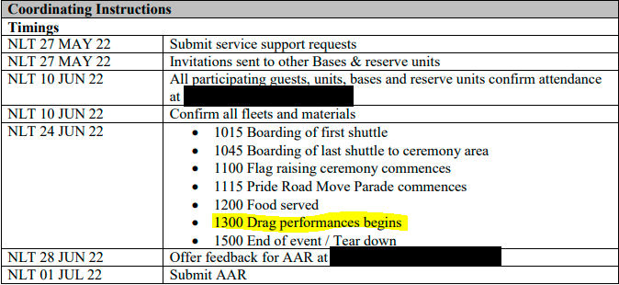
Behold, a partial screen shot of the Op Order! Drag performances? I’m not an expert, but I don’t think that veterans of the last world war would be entirely supportive of this; That the same military they fought a bloody war in would, ~80 years later, conduct drag performances for all to see. In fact, I think they might have got back on the boats and returned home, but then again, at least we aren’t speaking German or whatever…

There is something that I want you to keep in mind here: the CAF is supposed to be a politically neutral organization. Their mandate is to serve the sitting government, while being completely detached from any specific political party, or any organization that can be perceived as politically charged. The good corporal, for example, is not allowed to publicly support a political candidate in any capacity, because it would violate the entire organization’s duty to remain politically neutral. Why, then, is the CAF itself participating in gay events, something which have become inherently political? Double standards, again.

Redefining Chaplaincy
(Source: The Minister of National Defence Advisory Panel on Systemic Racism and Discrimination)
(Try saying that all in one breath)
For the unaware, chaplains are military members who work in the role of a faith leader, while also performing other related duties in the field of welfare. Their uniforms are much the same as other CAF members, with the exception of an additional accoutrement indicating their faith, with the most commonly seen one being a crucifix representing a variety of Christian denominations. Not all militaries have chaplains embedded as uniformed members like the CAF, but it is and has been common for military focused faith leaders to attend the spiritual requirements of soldiers across the globe, with forced-secular places like the former USSR being noteworthy exceptions. Chaplaincy has a long history in Canada, and one can find them working even within places like a brigade headquarters, advising the commander on matters of troop welfare, performing services, and even discussing the religious implications of a region for military purposes. Though the religiosity of the CAF has waned along with the rest of Canadian society (the cult of Covid notwithstanding) one still finds many members who seek their assistance in both religious matters and non-religious matters, and there is an expectation that soldiers can rely on them to provide denomination specific things such as sacraments, up to and including the Last Rites in Christianity, and parallel constructs in other faiths. The CAF itself states the following of chaplains:
“[They are] responsible for fostering the spiritual, religious, and pastoral care of Canadian Armed Forces members and their families, regardless of religious affiliation, practice, and/or belief. They have an open attitude and promote diversity within the Canadian Armed Forces by providing an environment that is caring and compassionate.”
Diversity has returned yet again. I suppose that if I were to search for the role of a diesel generator in the CAF, it would also be partially responsible for promoting diversity and inclusion. Here’s the problem, not all faiths are congruent with this definition. Islam, the favourite of the current regime, is very intolerant of the LGBTABCD crowd, as it is also with women. In fact, the Islamic debate on sodomy generally starts on the roof and ends on the ground. Orthodox Christianity is likewise sternly unsupportive of sodomy, though not with a violent twist. Roman Catholicism is supposed to be as well, but the pope is working diligently to sell his people down the river in that regard so we’ll need to wait and see.
Of course, the authors of the source document are fully aware of this, and are probably working tirelessly to delete from the chaplaincy any faith that doesn’t meet their diversity requirements:
“Another important point is that, at present, some chaplains represent or are affiliated with organized religions whose beliefs are not synonymous with those of a diverse and inclusive workplace. Some of the affiliated religions of these chaplains do not subscribe to an open attitude and the promotion of diversity.”
What are Catholics or Orthodox or Muslim members to do? Can they expect a chaplain to service their religious needs in the future? Not if the CAF gets their way. Presumably, they will be attended to by someone who means well enough, but whose religious affiliation is not in accordance with their requirements. The non-religious may not care, but this is an egregious violation of the principle of freedom of religion.
In case there were any doubt that this is specifically targeting non-reform Christianity, bear witness to this paragraph:
“It is necessary as well to recognize that, for some Canadians, religion can be a source of suffering and generational trauma. This is especially true for many lesbian, gay, bisexual, transgender, queer and twospirited members of Canadian society. And Indigenous Peoples have suffered unimaginable generational trauma and genocide at the hands of Christian religious leaders through initiatives such as Residential School and Indian Day School programs.”
Christianity bad! Christians are apparently expected to bear the shame of evil actions from other Christians, yet other faiths are obviously not. Imagine the uproar if Ukrainians claimed intergenerational trauma from Jewish Bolsheviks murdering and starving millions of their brethren in the 1930s. Every Jew from here to Tel Aviv would be kvetching about antisemitism until the planet were deaf, while furiously trying to blame it on Germans. What about the Balkan Slavs causing a ruckus over the centuries-long Ottoman (Islamic) occupation of their lands, complete with rape and slavery? The Turks would say they deserved it for being infidels, while simultaneously claiming it didn’t happen. But Christians can’t get away with that, at least not any Christian who even remotely follows the doctrine of the Bible.
“If the Defence Team rejects gender discrimination, anti-Indigenous discrimination, and racialized discrimination in every other area and is working hard to remove systemic barriers to the employment of marginalized people, it cannot justify hiring representatives of organizations who marginalize certain people or categorically refuse them a position of leadership.”
Aside from the fact that, actually, the Defence team openly endorses gender and racial discrimination, it is another double standard to pretend to avoid those things while discriminating by faith. Obviously their first goal is to purge the CAF of any Christian chaplains who don’t bend the knee to sodomy, but those who are looking ahead will find that this sets the stage for a purge of any members who declare themselves followers of said faiths. It is unlikely that they will be fired explicitly, as the CAF prefers to metaphorically kick its unliked members in the balls until they ‘voluntarily’ leave, then ask why everyone is leaving.

Redefining the CAF Dress Regulations
(Source: https://www.canada.ca/en/services/defence/caf/military-identity-system/dress-manual/changes-canadian-forces-dress-instructions.html)
A military uniform is supposed to be mostly consistent, with differences being for functional purposes like the indication of rank, recognition of medals, and denoting a person’s unit. The term uniform itself come from latin uni (one) and formis (form or style). The point of a uniform was to make everyone as similar as reasonably possible, outside of those functional differences, the idea being that when you wear it you now become equal to your comrades. The same principle of course applies to schools and workplaces that use them. Standards have always accompanied the porting of a uniform, such as an acceptable hair length, ironing of shirts, polishing of boots, and in many militaries, the shaving of facial hair. These standards, as well as the uniform, also serve as disciplinary thresholds outside of their primary purpose of uniformity. In the CAF, there have also traditionally been restrictions on things like tattoos, earrings, and personal sunglasses; How well would it reflect on the CAF if Cpl Smith had a tattoo on his face or lavish diamond earrings dangling from his ears? That would be ludicrous.
Fortunately, all of that archaic nonsense about uniformity and discipline will imminently be phased out, as the CAF has released their plan for an update to the dress regulations. Here is a snippet from the source on why they are changing it for the first time in 50 years:
“The appearance of the Canadian Armed Forces (CAF) has not kept pace with the Canadian society which it serves.”
The society which the CAF serves has become slovenly, stupid, lazy, diseased, degenerate, brainwashed, unmotivated, and rotten to the core. Should the CAF therefore mimic these fine qualities?
Before diving in to the changes, we should first be familiar with some exceptions to the dress regulations which have already happened. Firstly, a notable exception was made some decades ago regarding male Sikh members of the CAF, who are obligated by religious doctrine to port a turban and remain unshaven, thus deviating from the uniform standard. Secondly, beards had been authorized for certain members for either medical, occupational, or religious reasons (such as but not limited to above) for some time, and had actually been granted for all CAF members only a couple years ago if they so choose. Thirdly, long hair for men has been allowed for some time for religious or cultural reasons, such as but not limited to native members of the CAF. While these exceptions (not an exhaustive list!), especially the authorizations for Sikh members, were controversial, there was some reasonable justification provided for each one, even if one thinks the decision was ultimately wrong: At least the CAF tried to back up their decisions in these cases with reasonable effort. More importantly, these concessions were not egregious violations of the principal of uniform, and expectations for things like beards and long hair were that they are well kept and orderly. As far as turbans go, there is a matching colour scheme for a turban such that it matches the colours used by the corresponding normal headdress that other members wear. Again, many still disagree with these concessions, but you can’t say they didn’t try. The following alterations, on the other hand…
What wonderful changes have they made for the CAF this time? Let’s dig in:
“DEUs are no longer gender based. Both catalogues are open to all members and they may be intermixed. CAF members may choose their uniform design, which must fit them properly/professionally, as per the Dress Instructions. Some restrictions may be imposed in certain circumstances such as on parade.”
I’m not even certain if I should explain this one, as it should be self evident that this is hilariously wrong. However, it makes sense given that Canada is a country which believes men can be women, women can be men, and anyone who questions such mental illness is a thought criminal. In case you don’t understand the above paragraph, it means that men can wear skirts and pretend to be women, or that women can pretend to be men. Given that it is illegal to even look twice at these people, what sort of effect will it have on unit cohesion if Johnny decides to be Jane and wear skirts to work? Everyone will be terrified of getting locked up for wrongthink, and Johnny is now a walking threat. I’m sure that such a policy will really improve work ethic and retention!
“The following text has been removed: “Behaviour such as chewing gum, slouching, placing hands in pockets, smoking or eating on the street and walking hand in hand, is forbidden.” Does that mean CAF members can now do all those things when in uniform?
Pursuant to QR&O 17.02, the deportment and appearance of all ranks, in uniform or when wearing civilian attire, shall on all occasions reflect credit on the CAF and the individual. It is the responsibility and duty of all CAF members to ensure that, while in uniform, they comport themselves in a manner which projects a positive military appearance. Leaders at all levels have a role to play in this regard.”
More weasel words, I see. If that line has been removed, then the behaviour is implicitly or explicitly allowed. It says that leaders at all levels have a role to play, but they don’t have the support of a document to back them up anymore. If Maj So-and-so sees two soldiers doing these obviously inappropriate behaviours in uniform, he can’t do anything about it. If he tried to punish them, it would be thrown back in his face since the documentation no longer prohibits it. What would others think of our military if they saw soldiers doing these activities in public?
“Is unnatural-coloured hair acceptable in ceremonial orders of dress? And must accessories match the colour of hair?
Yes, the colouring of hair is permitted in all orders of dress unless it inhibits an operational duty. For example, bright coloured hair may have a negative operational impact during field operations or training. Leaders are invited to discuss with their members to find a simple, suitable accommodation, such as a scarf to cover the hair. Accessories do not have to match the colour of the member’s hair. However, all accessories shall meet safety and operational requirements and not must not discredit the CAF.”
Great, now the CAF is allowing rainbow haired creatures. This paragraph implies that members can dye their hair any colour they want unless it interferes with field operations. Green and purple haired peacocks violate the principle of uniformity in the same manner as one who wears a pink jacket instead of their issued pieces of uniform. Furthermore, such an action reflects discredit on the CAF by showing a blatant disregard for operational readiness: Certainly, most of the CAF isn’t going to deploy tomorrow to fight, but the principle of operational readiness is that they should be as prepared as possible to do so if required. It is for the same reason that CAF members are expected to maintain their physical fitness. What if Cpl Freakshow were to deploy tomorrow to fight somewhere? As mentioned above, they can choose to cover their hair with a scarf or something, but is that not an additional and unnecessary burden on their ability to remain camouflaged? Should they smear their hair with mud so the enemies don’t immediately see them? Shave it off completely?
The Russians must be quaking in their boots, but from laughter rather than fear. As if these aren’t bad enough, they intend to review it periodically and will likely make more changes:
“Going forward, the intention is to continually review the updated Dress Instructions, in order to provide additional clarity where necessary and to include any elements previously overlooked.”
Why maintain cohesion and retention when you can shill for inclusion instead? Of course, the sort of people the CAF needs are precisely the ones who will be turned off by these concessions, and will likely refrain from signing up, or consider releasing if they are already in.

A note about White supremacy
Where is all this White supremacy that they are complaining about so much? If we look at their definition of White supremacy, as per the source for the chaplaincy section, we find the following:
“The term “white supremacy” is often misunderstood. For this report, the following definition is used: white supremacy “is the idea (ideology) that white people and the ideas, thoughts, beliefs and actions of white people are superior to People of Colour and their ideas, thoughts, beliefs, and actions. White supremacy expresses itself interpersonally as well as structurally (through our governments, education systems, food systems, etc.).” A white supremacist is “a person who believes that the white race is inherently superior to other races and white people should have control over people of different races.”
Interesting. I have not met a single military person who meets both categories, though there must be at least a few somewhere. There are some that I have met who might believe Whites are superior (it’s hard to tell without explicit comment), but I would be hard pressed to find someone who really thinks Whites should rule others. But what would we call someone who thinks that Whites are inferior to others, and that Whites should be ruled by others? Because there are magnitudes more of them than there are alleged White supremacists, including the regime itself since such an attitude is explicitly permitted. Obviously, the CAF couldn’t care less, as they wouldn’t have any standards if not for double standards.
Unfortunately, the CAF (and its parent regime) will get precisely what it wants in this witch hunt, as it is actively creating White supremacists and ardent White racists (and those of other races too!) through their continued efforts to divide everyone along racial lines, give preferential treatment to certain groups, and promote racial conflict. Whites who just wanted to live peacefully with others are becoming quickly aware that such a future was never going to happen, and situations like these may transform those individuals into the most adamant racists you could imagine. Hitler’s NSDAP and Mao’s communist party did not appear spontaneously. Romanians didn’t execute Ceaușescu because it was a fun thing to do on a Monday. The US civil rights movement didn’t happen because Blacks just happened to collectively feel like it. These situations were the products of years of perceived injustice, and the CAF would do well to take note. A better example might even be the Vietcong during the Vietnam war, who found otherwise disinterested farmers joining their ranks after getting picked on by American forces for no reason other than their race. While the CAF would like to [pretend to] solve the unsolvable retention problem, their propaganda may generate a far more insidious problem of a similar nature. All they had to do was leave people alone, but that was a bridge too far. Obviously, this nonsense comes directly from the feds, who likely have a variety of nefarious reasons for it, none of which will benefit the people or the CAF regardless of their skin colour.
For those interested, here is a good interview on the subject of the Vietnamese, which is quite relatable in a few ways to the topic of this paper: https://www.youtube.com/watch?v=tixOyiR8B-8 (Approximately 15 minutes in length)

Faith in the Chain of Command
All around me there is treachery, cowardice, and deceit
-Saint Nicholas the Passion-Bearer, last emperor of the Russian Empire
In the introduction, I mentioned how working conditions in the CAF are generally good. There is a caveat to that, one the size of the national deficit. In fact, you can call me a liar if you want to. Do you know what a Chain of Command (CoC) is? It is a term which refers to the hierarchy of authority encompassing leaders at all levels upwards and downwards. For example, in an army battalion, the CoC might start with the Commanding Officer (CO), then company commander, then platoon commander, then section commander, if you were to go in descending order. At any point in that chain, a leader has the responsibility to interpret orders from their superior, voice concerns or ask questions, then deliver a subsequent set of orders to their subordinates and listen to their concerns. There is also an understanding that subordinate leaders report items of interest or concern to their superiors as required, so that all levels of authority have the information needed to make effective decisions. Keep this in mind as well: All militaries employ civilians (non-uniformed members) to some extent, and they are subject to different rule sets than military folks, thus adding complication to the issuing of orders and legal responsibilities.
What about orders that seem questionable? How does the CAF (or any military) deal with such a thing? In theory, it is the responsibility of every member to refuse an order if they know it to be unlawful. If Sgt Bobandy told his section to go and steal cheeseburgers from McDonalds, that would be obviously illegal and his section should tell him to frigg off, before bringing it up with the platoon leader or someone else. Alternatively, if the platoon leader had a craving for illicit American delicacies, we should expect the Sgt to tell him off and defend his section from such an order. That is one of the roles of a leader; They should be ready to put themselves in uncomfortable positions if needed, such that righteousness prevails and their subordinates are looked after. In ambiguous situations where the order isn’t immediately obvious as unlawful or unethical, things become more complicated, but a leader is still expected to make a decision that they can justify later even if it turns out to be wrong. This responsibility extends all the way to the highest office in the uniformed land, that being the Chief of Defence Staff (CDS).
Of course, such an attitude should extend to all activities, not just explicit orders, and not just orders which seem legally or ethically questionable. If X platoon is asked to clean garbage in the front yard, but Z platoon is obviously the group responsible for the garbage, would you not hope that the leader of the former at least tries to avoid the task since their troops are not the culprits? Sure, the unit CO will likely say don’t-care-didn’t-ask, but one would hope that their platoon commander puts some effort in to protecting their interests, even if it’s just an hour of picking up rubbish.

We need to talk about the jabs…
With this foundation laid down, we first need to talk about the elephant in the room: The coronavirus pandemic and the vaccine debacle. When the whole thing started [for the CAF] back in March of 2020, the world was on edge and nobody knew how serious it was. You likely recall dubious videos of Chinese people being welded into their apartments, mass graves, and extreme hysteria. Even here, people were wearing painting masks and drowning themselves in hand sanitizer over a then enigmatic danger. Likewise, the CAF took a serious approach to the threat, recalling people from leave overseas, providing masks, providing sanitizer, and monitoring very closely the symptoms of members. This was a reasonable initial response to the threat, since its parameters and true risk weren’t known. In fact, I commend them for actually doing something, anything, unlike the feds who couldn’t have cared less about letting foreign flights deposit the disease freely.
But by the end of the summer that year, it became clear that the masks didn’t do anything, at least not against viruses. It also became fairly clear that the virus itself was of negligible danger to anyone who wasn’t already in danger for other reasons, like the elderly and morbidly obese, neither of which are [supposed to be] descriptors for CAF members. More importantly, it became completely clear that regimes around the world, including ours, were milking the crisis for as much consolidation of power as possible. But there was the potential to lessen the (negligible) risk, or so we thought: experimental medical products misleadingly called vaccines were on the way to save us! Here is an excerpt from a January 2020 Defence Team Message on the subject:
“As your Surgeon General, I have some good news to share with you after what has been an unprecedented year (2020) with the COVID-19 global pandemic having a profound impact on every Canadian.
I want to assure you that there is light at the end of the tunnel. As we welcome the New Year, we are also taking the first steps in the launch of the COVID-19 Canadian Armed Forces (CAF) vaccine rollout for members of the CAF. Immunization of CAF members will begin in this month and will adhere to a CAF Vaccine Prioritization Framework which I will explain below.”
Sounds good to me, as long as it remains optional. Indeed, lower in the message, the optional nature of this program was stated explicitly:
“Like other vaccines provided to CAF members, the COVID-19 vaccine will not be mandatory; this remains a voluntary option for all. Whether or not a vaccine will be made a requirement for an operation or a position is a decision to be made by operational commanders, in consultation with their medical advisors. However, CAF members may require proof of a COVID-19 vaccination in order to operate in certain high-risk environments or with vulnerable populations. The intent remains to protect ourselves, and protect others to maintain operational effectiveness as we serve Canada and Canadians at home and abroad.”
The above paragraph is in line with other CAF vaccines. Since approximately the dawn of time, it has been expected that CAF members take certain vaccines in order to deploy to particular zones, given the risk of disease in those areas. That isn’t an entirely unreasonable policy, I’d say. This email, however, aged like a military vehicle in a road salt province.
As per the CDS Directive from Autumn of 2021, CAF members must partake in the medical experiments corresponding to the virus. What about CAF members who don’t want to, either due to religious reasons or personal opposition to the medical product? The Queen’s Regulations and Orders (QR&Os, one of many documents governing the CAF) Volume II, Chapter 103 states the following:
“126. Every person who, on receiving an order to submit to inoculation, re-inoculation, vaccination, revaccination, other immunization procedures, immunity tests, blood examination or treatment against any infectious disease, willfully and without reasonable excuse disobeys that order is guilty of an offence and on conviction is liable to imprisonment for less than two years or to less punishment.”
The without reasonable excuse is their ticket out of this, or so we would hope. Religion is a fundamental excuse for such things, at least it was until recently. A variety of religions prohibit vaccines for different reasons, or accommodate the prohibition of certain vaccines based on balance of sin and benefit, given the nature of creating such medical products. What about members who don’t want it because of non-religious reasons? Given that the virus itself is of negligible harm, the ‘vaccines’ could not possibly provide anything other than negligible benefit. The risks of these products, of course, are still not completely known, though they now appear to be both slightly harmful and of negative effectiveness against the virus. Is that not a reasonable excuse to say no?

Sergeant Kipling and the anthrax vaccine
(Source: https://www.theglobeandmail.com/news/national/charge-stayed-as-anthrax-vaccine-ruled-unsafe/article4163546/)
This isn’t the first time that such an order has been given. In the 1990s, USA-provided anthrax vaccines were ordered for select CAF members corresponding to their involvement in operations in the middle east. As you may or may not know, those vaccines were also experimental and are now widely reputed for causing harm to many who took them, including chronic and debilitating illness. [Then] Sergeant Kipling was one CAF member who refused the vaccine, and was brought to trial over it. In fact, Mr Kipling had taken the same vaccine previously in the early 1990s for a different operation, but reconsidered his stance after learning of its dangers:
“Mr. Kipling has said that he was injected with the anthrax vaccine when he served in the Persian Gulf war in 1990, but that subsequent reading he had done on the subject lead him to fear its effects on his health.”
He was charged, but the trial process eventually ruled in his favour:
“Canada's top military judge has stayed a charge of insubordination against a former air force sergeant who refused a dose of anthrax vaccine, ruling that the Charter of Rights and Freedoms protects Canada's soldiers from being forced to take unsafe drugs.
…
When Sergeant Mike Kipling's superiors ordered him to take the vaccine without his informed consent they infringed upon the serviceman's right to life, liberty and security of person as enshrined in the Charter, the judge ruled.”
What similarities can we draw between this and what is happening now?
-an experimental vaccine was ordered for CAF members
-the medical product was used under emergency authorization
-informed consent was not given to those members (I’ll come back to this)
-there were known risks with the medical product
-member(s) who leveraged section 126 of the QR&Os were crucified by their CoC
History certainly does repeat itself. Why should a member have any faith in a CoC which blatantly violated precedents that were set against that very same CoC previously? To be clear, the personnel have changed since the Windows 98 era, but the same CoC still exists, and is expected to remember important decisions and precedents like this one. And yet, despite this, the current CoC has explicitly ignored a case which bears nearly complete similarity of principle to this virus clown show. Force medical experiments on me Fool me once, shame on you, fool me twice, shame on me [the CAF members] I guess. Remember the unlawful orders discussion above? If the CoC in the CAF actually cared about its principles, precedents, and ethical guidelines, none of the current ridiculousness would have ever happened; Anyone under the order-writer would have referred to Mr Kipling’s case and said no. Instead, we have a cascade of authority levels bending the knee and threatening their subordinates to do the same, lest someone declare that the emperor has no clothes.
What about the civilian members which were briefly mentioned above? As you can probably guess, civilian CAF employees are not subject to the same rules of employment as CAF members, for hopefully obvious reasons. A plainclothes CAF employee who makes spreadsheets for a living can’t be ordered to go shoot Taliban, that would be most heinous! Subsequently, civilians are governed by federal and provincial employment law, including the principle of constructive dismissal. Let’s just use this explanation from an Alberta law firm which explains it quite well, though you can read more in the official federal documentation on the subject if you want:
“In terms of employment law, constructive dismissal is basically a fancy way of saying that your employer made such drastic changes to your role, terms of employment, or work environment that you were forced to leave your position. If you did not agree to these changes, you may have the grounds to make a claim.”
What do you notice here? How does it bear similarity to what has gone on in the world of civilian employees of the federal government, including the CAF? It bears similarity in a complete and unequivocable way to the federal employee vaccine mandate which was ordered in October 2021. Here is a screenshot from that document:
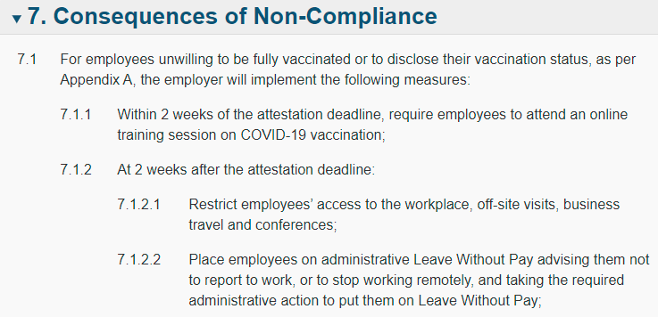
Aside from the questionability surrounding the demand for private medical information, the change in terms of employment (mandating jabs) and the consequences for failing to adhere (leave without pay and coronavirus struggle sessions) are textbook definitions of constructive dismissal. Any military (or civilian) CAF member who actually enforced this nonsense 1) should be utterly ashamed of themselves 2) violated federal and provincial law by definition, and 3) enforced unethical orders, even aside from their explicit unlawfulness. Sure, this policy doesn’t directly apply to CAF members in the capacity as an employee subject to it, but what faith should a CAF member have in their CoC if it were to have enforced this mandate? I’ll help you with that answer: They should be utterly disgusted and seriously question their place within such an organization, regardless of their personal views on the jabs. Many CAF members I have spoken to in the process of writing this piece share precisely this view, though they haven’t spoken out publicly for (justified) fear of retribution. More concerningly, many CAF members don’t share this view, and they are precisely the sort who would have been found enthusiastically operating the gulags in another place and time.

Informed consent
(Source: https://media.tghn.org/medialibrary/2011/04/BMJ_No_7070_Volume_313_The_Nuremberg_Code.pdf)
I mentioned a principle called informed consent above, which I would like to explain and discuss. After the last world war, trials were held in Nuremberg for war crimes perpetrated by the Germans which happened during the conflict. While some aspects of the trials are considered questionable (allegations of torture, refusal to also try the allies, and Ex Post Facto law for example) it is widely lauded as the first establishment of international criminal law against individuals. One of the trial subjects was accusations against the Germans of medical experimentation under coercion or other unacceptable circumstances, and arising from this was a document called the Nuremberg Code. The first paragraph of the code defined informed consent:
“The voluntary consent of the human subject is absolutely essential. This means that the person involved should have legal capacity to give consent; should be so situated as to be able to exercise free power of choice, without the intervention of any element of force, fraud, deceit, duress, overreaching, or other ulterior form of constraint or coercion; and should have sufficient knowledge and comprehension of the elements of the subject matter involved as to enable him to make an understanding and enlightened decision.
This latter element requires that before the acceptance of an affirmative decision by the experimental subject there should be made known to him the nature, duration, and purpose of the experiment; the method and means by which it is to be conducted; all inconveniences and hazards reasonably to be expected; and the effects upon his health or person which may possibly come from his participation in the experiment.”
Does threat of unemployment sound like anything written above? Does it perhaps resemble force, fraud, deceit, duress, overreaching, or other ulterior forms of constraint or coercion? Yes, of course it does! Threatening unemployment for refusing to take an experimental medical product meets that definition explicitly, and the coronavirus ‘vaccines’ are indeed experimental until complete approval is gained after complete trials, therefore implicating this code. Was anyone in Canada, let alone the CAF, informed about the nature, duration, and purpose of the experiment; the method and means by which it is to be conducted; all inconveniences and hazards reasonably to be expected; and the effects upon his health or person which may possibly come from his participation in the experiment? Of course not, they were simply told that it’s safe and effective, neither of which appear to be true. Nobody was even informed explicitly that they were partaking in something which is, by definition, a medical experiment. The products weren’t even considered vaccines until the definition for a vaccine was conveniently changed such that they would be included.
We have therefore established that the CAF, and the regime it serves, have explicitly violated this code, and knew or ought reasonably to have known as such. The whole point of the Nuremberg Code, itself a consequence of our own involvement in the European conflict, was to ensure that such vile things never happened again, under any circumstance. If the principles we fought for are so casually tossed aside by the very organization that fought for them, what was the point? Why did we even bother fighting the Germans at all, when we now embrace their sins? Why should any self-aware CAF member have even a shred of respect for the organization when it openly discards its history and sacrifices? I don’t have an answer, and apparently the thousands of CAF members now leaving its ranks due to this ridiculous experiment don’t either, let alone the civilians who have left their posts as federal employees.
As if to add insult to injury, the federal government recently rescinded the federal employee mandate, without so much as a hint of repentance or an apology:
“As of May 30, 2022, 2,108 federal employees, or less than 2%, were on administrative leave without pay, as a result of declining to disclose their vaccination status or because they were unwilling to be vaccinated with two doses. These employees can now resume regular work duties with pay.”
After having a knife in their back since October 2021, they can now resume regular duties? What about the last 9 months of unpaid shunning? What about compensation for any financial losses they incurred as a consequence? How utterly and unfathomably insulting. I certainly hope that these employees sue the feds for every single penny they possibly can. While those responsible ultimately deserve to be shot, at least an extortionate transfer of funds would be a symbolic, if pyrrhic, victory.

Fear and Loathing at the Royal Military College
(Source 1: https://www.thewhig.com/2015/05/21/activist-educator-recalls-hostile-experience-at-rmc)
(Source 2 : eyewitness accounts of events at RMC)
(Source 3: https://www.canada.ca/en/department-national-defence/corporate/policies-standards/defence-administrative-orders-directives/9000-series/9005/9005-1-sexual-misconduct-response.html)
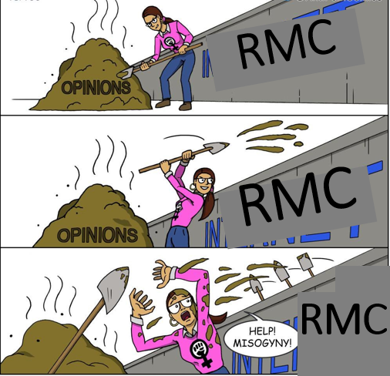
Back in 2015 or thereabouts, there was a furious fervour happening at the Royal Military College (RMC) in Kingston. For the unaware, RMC is the CAF’s primary officer training hive, and the term college is misleading as it actually functions at a university level. At that time, all sorts of allegations and charges and investigations were happening around the subject of sexual assault, misconduct, and harassment. Some CAF members who I have spoken to were there at that time, and confirmed that there were and had been quite a few accusations made, investigations conducted, and charges laid. Was there more nefarious activity than had been the historical norm? Who knows, but the leadership of RMC, along with the CAF in general, were in hot water and needed to make it look like they were doing something. As is a common answer in the land of uniforms, more briefings was the answer! RMC stepped up the focus on briefings on these subjects. A rather high-profile activist on the subject, Julie Lalonde, was brought in to deliver a set of related briefings focused on consent to the students, as divided by the year (1st year students in one group, 2nd year in another group, etc). As corroborated by the then-students I spoke to, her very first words were to totally dismiss the possibility of sexual misconduct etc against males, and she then proceeded to, in other words, target them as implied guilty parties by virtue of existing. What did she hope to achieve by doing this to an audience which was probably 80% male? At best, one would expect them to then turn off their brains and wait for such a briefing to end. Interestingly enough, the female students in several of the groups apparently began throwing Ms Lalonde’s own one-sidedness back at her, which surely must have caused some rage. I suppose the males understood (correctly!) that even breathing the wrong way would have made pariahs of them. This didn’t go so well, and Ms Lalonde quickly took to social media afterwards to screech about her experience:
"What I experienced at RMC was hostility that was palpable. You could walk into that room and feel the tension. I really feel like ... I was set up by the institution."
Were I to conduct a briefing to students of Chinese military colleges on the evils of eating dogs, while implicitly blaming each attendee as an assumed guilty party, would I not also reasonably expect some tension? Seriously, did she not expect some hostility when she herself brought a bag of it? The following, I think, is a good summary of the problem:
"Probably half the time I was there (it) was them very aggressively arguing that alcohol-facilitated sexual assault is not a problem, it's women making poor choices," Lalonde said. "They were unbelievable. Literally getting up, clapping, cheering when someone would insult me."
A discussion on something as serious as sexual misconduct etc should probably be a two-way street, otherwise it’s not much of a discussion at all. Let’s take an analogy: If you left a computer on the seat of your (locked) car, and came back to find the window broken and the computer gone, who would be to blame? Obviously, the scoundrel who stole it is to blame, but could you have possibly protected yourself by making different decisions? Of course, you could have brought the computer with you, thrown a blanket over it, or a myriad of other, better choices, none of which change your status as the victim. So it is, sort of, with the topic of these presentations. As per above, maybe (definitely) there is room for improvement in the drunken-harassment world, but it would be nonsense to discard a discussion on how the other party might best protect themselves against it. But toxic neo-feminism is having none of that, as acknowledging the reality of an imperfect world implies taking responsibility for oneself instead of blaming the nearest penis.
Ms Lalonde obviously wasn’t happy with the outcome. She alleges that some of the students cat-called or otherwise made untoward comments and gestures. The alumni I spoke to deny this as true, so I am not going to assume authenticity of either account in this regard. Of course, RMC and the CAF at large embraced tradition for once and bungled their response, by demanding first that Ms Lalonde prove it, then by apologizing later. Subsequently this event contributed to the oft-maligned Op Honour which came out shortly afterwards, seeking to address sexual misconduct CAF-wide. It is worth noting that none of the CoC were actually present for the briefing, which is a rather stupid mistake. Maybe the CoC were wasting time with their own briefing, who knows.
How is this related to CoC, then? As mentioned in the article, the whole thing was set to fail from the beginning. RMC leadership had selected a presenter with an axe to grind, and set her against a mainly-male audience, all on a Saturday. As an explainer, RMC students have generally strenuous weeks, so those weekends which they have free of other activities are considered quite precious. By taking away a Saturday (as decided by RMC) to pit Ms Lalonde against them, there was hostility pre-made even regardless of the topic of conversation. What about afterwards? According to the students I spoke with, since Ms Lalonde went public about how those evil RMC students had treated her so poorly, those at the institution began implicitly punishing the entire student body, and doubled down on even more briefings. Certainly they needed to account for the fact that Ms Lalonde might not have been exaggerating, but assuming their own people guilty, as the CAF now does as an institutional policy on sexual misconduct et al, is a knife in the back of their own members (another tradition of theirs). The Julie Lalonde saga, of course, is one of many related incidents and contributing factors, but has been selected as one of the more noteworthy ones.
As per source 3 of this section, the CAF assumes victim status of anyone who reports that they have been the victim of sexual misconduct. It is written right in the source document, where the term victim is used throughout, in spite of the fact that innocence [of the accused) is supposed to be assumed until proved otherwise, at least in any legal framework worth respecting. Furthermore, according to section 6.3 of the source document, the burden of evidence is a balance of probabilities (as per civil law) rather than proof beyond a reasonable doubt (criminal law). This makes it far easier to convict someone, and the former is used in things like property disputes, whereas the latter applies to things like murder. Which one do you think applies to sexual misconduct more appropriately? While neither approach is perfect in the case of something like sexual misconduct, the civil law approach is quite a poor choice in something with such severe consequences for those convicted, especially given the general lack of concrete evidence in such cases. This, combined with the CAF’s explicit prioritization of all things female, could reasonably ensure that male CAF members view both women and their CoC as enemies who will condemn them with nothing more than a show trial should something occur.
To be absolutely and completely clear, neither this paper nor the author takes any stance regarding sexual misconduct other than explicit and profound condemnation of the action. Rather, this is a criticism of the CAF for failing to uphold ethical and established legal principles when dealing with such a serious aberration, and subsequently failing to stand up for both the truth and the interests of its own members in the face of the easy route called social justice.

Don’t cry because it’s over, smile because it happened!
Most of the American politicians, media, and educational system trains another generation of people who think they are living at the peacetime. False. United States is in a state of war: undeclared, total war against the basic principles and foundations of this system.
-Yuri Bezmenov, KGB defector

A. Grandpa’s car
Suppose you were given a car from your father, who himself received it from his father. For fun, let us pick a specific one. I’m fond of the 1957-1959 Plymouth offerings:
Grandpa, of course, bought the car new in ’58, and drove it for many moons. He kept it running smoothly for 30 years, then your father inherited it. You remember it fondly from your childhood, burned into your brain as a chariot of fun for weekends and shenanigans. You didn’t notice the deteriorating condition or neglected maintenance, because kids don’t really pay attention to those things. But when your father passed it your way, things weren’t looking so rosy. It became obvious that daddio had completely ignored basic things like brakes and carb tunes and oil changes, and the interior had not been cleaned in a dog’s age. In fact, the car could no longer start, stop, move, or keep water out, and it had been sitting in the backyard for years. Thanks dad!
Where do you start in repairing a vehicle in such a sorry state? Usually, people start with the engine and gearbox, then brakes, followed by power steering and electrical stuff. Redoing the interior and body panels comes later. Regardless, you need to start somewhere, and go everywhere. It can be an astronomical load of work, but in almost any case, a car can indeed be brought back to life if enough effort, time and MONEY are put into it. After all, a car has a finite number of tangible parts, all of which can be repaired or replaced. If a car isn’t functioning as it should, or doesn’t look as it should, the issue can be fixed because it exists solely in the material plane.

The mission of the CAF
But we aren’t talking about a beautiful old car. The Canadian forces also has tangible physical components that can be repaired or replaced. All militaries do. Our mediocre vehicle fleet could be entirely replaced, or entirely repaired, or a mix of both. Our buildings could be fixed or repaired, as could our networks and aircraft. We could even buy more of these things if we wanted to, but the difference it makes would be limited. A military consists largely of the human component, which isn’t subject to the same laws as a building, tank, or rusty Plymouth. Humans aren’t rational, and don’t operate entirely on facts, much as we wish that were true. Humans require reasons and justifications and motivation and belonging and a variety of other abstract concepts to function properly.
To be frank, addressing the absolute state of CAF military equipment would be pointless here. Suffice to say, it’s not good, and will likely not get better in the near future. Much of this is a result of the retention problem, as there aren’t enough people to keep up with maintenance.
An entirely new fleet of military vehicles, base housings that isn’t mouldy, and buildings that don’t have asbestos would significantly increase morale. I even postulate that it would improve the retention problem. It would not, however, solve the most dire problem with the CAF: Why does it exist? What is it that the CAF stands for and against? The mission statement of the CAF is this:
“To defend our country, its interests and its values, while contributing to international peace and security”
This statement requires a closer look. First of all, we can delete the international peace and security bit, because right now, we are concerned with Canada. That leaves us with the defence of Canada, and its interests and values. One can harm a country through physical violence, but one can also harm it through subversion, economic shenanigans, or infiltration. Therefore, to defend a country, one would need to prevent or stop military incursion, as well as non-violent means.

Defending the country
The CAF stopping a military incursion? It’s a laughable premise for few reasons. Firstly, nobody would invade us militarily, not as long as the United States exists. NATO article 5 would mean that anyone who invades Canada would therefore be at war with the USA. Secondly, assuming the USA collapsed (not entirely unlikely, these days) that would leave the CAF alone in defending Canada against a foe. Let’s say either China or Russia, maybe both. Who would win, the CAF or the People’s Liberation Army? I don’t mean to disparage the hardened soldiers in the CAF; I am certain that they are, person-to-person, better trained and more capable than their PLA counterparts. But when a few thousand CAF soldiers are facing the most populous military in the world, the battle is somewhat pointless and we might be better off making coffee and studying mandarin as they roll through. This would apply to the Russians as well, though with slightly different parameters. Keep in mind, uniformed CAF members hover around 90,000; how many of those are injured, or exclusively administrative, or gender bending advisors? How many are prepared to fight off an invasion in Vancouver tomorrow? The PLA ground force has 975,000 active duty personnel. To clarify, their regular force army alone has nearly ten times the number of our entire military force, reservists included. Just their army, we aren’t even taking into account their navy, air force, or rocket force. Yeah, we aren’t defending shit.
Fortunately, this is almost certainly never going to happen. China hasn’t even bothered to take Taiwan, right next door. They’re not going to storm the beaches of Vancouver in search of BBQ duck and noodles, or cars that don’t break every seven minutes. They’re not going to do it, because they don’t need to; it is far easier for them to subvert and infiltrate a region economically than it is to drive in, guns blazing. In fact, they have already been doing that in Canada for decades. This article is from 2000, and makes reference to investigations from the late 1990s:
https://www.theglobeandmail.com/news/national/china-set-up-crime-web-in-canada-report-says/article4163320/
If you know someone who overdosed on illicit opioids, they probably came from China. If you know someone who uses a Huawei phone, they can thank Nortel (RIP) for the stolen technology inside. China isn’t the only maggot on the corpse, of course. How about the recently lambasted World Economic Forum? What started as a conspiracy fact has now become a household name, much to their chagrin. These paragraphs from Swiss Policy Research explain it quite well:
“Finally, the WEF has been running, since 1993, a program called “Global Leaders for Tomorrow”, rebranded, in 2004, as “Young Global Leaders”. This program aims at identifying, selecting and promoting future global leaders in both business and politics. Indeed, quite a few “Young Global Leaders” have later managed to become Presidents, Prime Ministers, or CEOs (see below). In a speech in 2017, WEF founder Klaus Schwab described this process as “penetrating the Cabinets”.
In a speech in 2017, WEF founder Klaus Schwab mentioned Canada as an example of how the WEF “penetrated the Cabinets” and said that Canadian Prime Minister Justin Trudeau and “more than half of his Cabinet” were Young Global Leaders (1:08:30), but this may have been an exaggeration.
Canadian PM Justin Trudeau has been a WEF keynote speaker, but he is not a confirmed Young Global Leader. Confirmed Young Global Leaders in his Cabinets since 2015 include Deputy Prime Minister Chrystia Freeland (selected in 2001; former managing director of Reuters and a member of the WEF Board of Trustees), Minister of Foreign Affairs Mélanie Joly (2016), President of the Treasury Board Scott Brison (2005), Minister of Immigration Sean Fraser (2022), and Minister of families Karina Gould (2020). Other Cabinet members were speakers at the annual WEF meeting in Davos. Mark Carney, former Governor of the Bank of Canada, is a member of WEF Board of Trustees.”
The link is here, if you want to read more: https://swprs.org/the-wef-and-the-pandemic/
It seems quite clear that at least one supranational organization has infiltrated the Canadian federal government at a rather high level, though those who have been paying attention can likely list a few dozen more. This isn’t even tin foil hat material anymore; It can be easily verified. How can the CAF defend the country against a shady international organization that now influences its boss? It’s simply not possible, short of a military coup. As for defending the interests and values of Canada, what are they?

Defending Canadian Values
(Source: https://www.canada.ca/en/department-national-defence/corporate/reports-publications/duty-with-honour-2009/chapter-2-statement-of-canadian-military-ethos/section-3-canadian-values.html)
According to the source for this section, Duty with Honour, we find the following laid out as Canadian values:
“Such values as the democratic ideal, the concept of peace, order and good government, the rule of law, and the strength to be drawn from diversity”

Diversity
As described extensively in the first section of this paper, the ‘strength’ drawn from diversity has been infighting, race-baiting, and destruction of societal and military cohesion, all at the expense of what is important; There is no need to repeat the discussion again. Diversity of thought would be different, but that is absolutely verboten in Canada and the CAF.

Rule of Law
Rule of law? The stupidest pandemic in history has removed any shred of it that was left. Medical discrimination is illegal, but we have vaccine mandates for jobs, travel, border crossings, and more. Invading a church service is criminally illegal, but cops stormed into churches during the pandemic without consequence, multiple times, because the congregation were violating gathering restrictions exercising their rights. Inter-provincial travel restrictions are unconstitutional, yet a variety of checkpoints and rules popped up over the last two years in direct violation of basic rights. As already mentioned, the law is applied differently based on the race and gender of the perpetrator, for the same crime. The prime minister himself violated ethics law in the SNC-Lavalin fiasco, but obviously he wasn’t punished because rule of law doesn’t apply; Some animals are more equal than others. Canada is a country in which rule of law is a farce of its own principle.

Peace, order, and good government
Peace, order, and good government is an interesting statement. Every boomer-tier newspaper comic since the dawn of time has complained that our government is bad, but they don’t actually understand why. It is bad because its core documentation is full of holes; Specifically, the charter of rights and freedoms is deliberately awful. This is the first paragraph:

Rights and freedoms in Canada
“1 The Canadian Charter of Rights and Freedoms guarantees the rights and freedoms set out in it subject only to such reasonable limits prescribed by law as can be demonstrably justified in a free and democratic society.”
We have rights given by government, unless they want to restrict them by justifying the restrictions to themselves. This would make them more like privileges. How about section 15?

Equality before and under law and equal protection and benefit of law
“15. (1) Every individual is equal before and under the law and has the right to the equal protection and equal benefit of the law without discrimination and, in particular, without discrimination based on race, national or ethnic origin, colour, religion, sex, age or mental or physical disability.
Affirmative action programs
(2) Subsection (1) does not preclude any law, program or activity that has as its object the amelioration of conditions of disadvantaged individuals or groups including those that are disadvantaged because of race, national or ethnic origin, colour, religion, sex, age or mental or physical disability.”
Equity comes back to rear its head again: People can’t be discriminated against for immutable characteristics unless government says that they can be discriminated against for immutable characteristics. Remember our mentions of equity earlier? It’s a big problem. Below, see a definition of equality when compared to equity. This one is from George Washington University, but you will find similar definitions in a variety of places:
“Equality means each individual or group of people is given the same resources or opportunities. Equity recognizes that each person has different circumstances and allocates the exact resources and opportunities needed to reach an equal outcome.”
Here’s the TL;DR: Equality = same opportunity, equity = same outcome. I certainly hope you can see why this is a problem. Remember your parents’ half-assed explanations of communism from when you were a kid? It probably included a description of how doctors and burger flippers made the same money, despite one being vastly more skilled and responsible than the other. That is equity. Maybe this image explains it better:
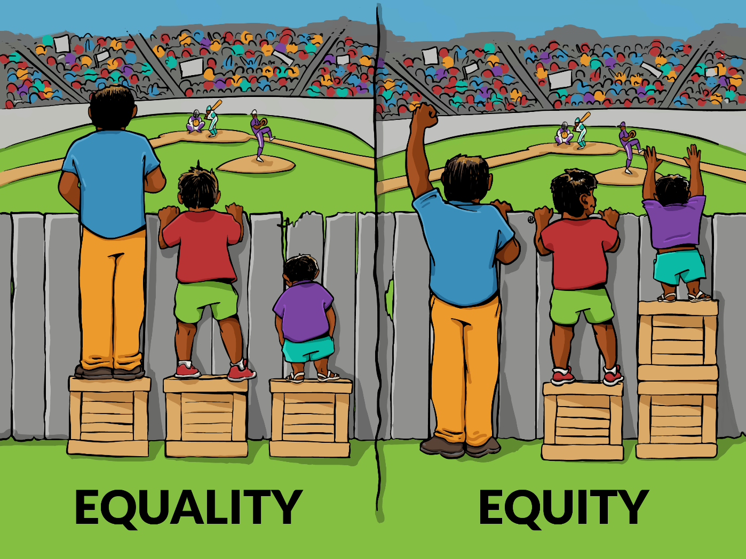
This image obviously is shilling for equity, but it inadvertently explains why it is so bad. See the purple shirt guy? Whose problem is it that he can’t see the game? Not yours, and not mine. It is his problem alone. It’s unfortunate that he is too short to see without additional crates, but that is his issue to solve. The blue shirt guy, alternatively, is tall enough to see without any additional stuff to stand on, and the red shirt bloke only needs one. Good for them. In the second pane, these crates have been redistributed such that all can see. I suppose that at a ball game, it is reasonable to expect that crates were willingly given to others, but society is not a ball game, and redistribution in real life happens at metaphorical gun point. If your wealth is confiscated to support those with less, why bother working at all? If you are arbitrarily held back from promotion so that more ‘diverse’ people can get ahead for no good reason, why bother putting in the effort? Equity is the undoing of any organization larger than a few dozen people, because humans are not created equal, and forcing an equal outcome is abominable and an affront to nature. The end result is a society of purple shirt people clamouring for crates that don’t exist, because all the blue shirts either fled the country or decided to become welfare NEETs.

On to section 24:

Enforcement of guaranteed rights and freedoms
“24. (1) Anyone whose rights or freedoms, as guaranteed by this Charter, have been infringed or denied may apply to a court of competent jurisdiction to obtain such remedy as the court considers appropriate and just in the circumstances.”
If your rights (privileges) were infringed, you can kindly ask a court to remedy the problem. They will ask that a government representative justify the infringement. Then, you get a remedy, or not. Either way, it will be too little too late; This allows government to shoot (your rights) first and ignore questions later. Let’s say, for example, that a government mandated experimental vaccines gene therapy to continue working for them. I know, what sort of horrible regime would do that? Anyways, at that point you could quit, become destitute, live under a bridge, and wait for the court to deem the restriction unacceptable. Or, more likely, you bend over and take the infringement in the ass, then complain on Facebook. What good is a court victory if you go broke waiting for it? I know not if other countries have the reverse, but it would be the correct way to do things; government requests an infringement, then spends their time justifying it.
If the core document that guides our government is this useless, how can the government itself be expected to be good? Outside of good government, the statement includes peace and order. Credit where credit is due, those two tenets are somewhat reasonable, all other factors being equal. Just as a point of comparison, let’s look at the first amendment from the American constitution:
“Congress shall make no law respecting an establishment of religion, or prohibiting the free exercise thereof; or abridging the freedom of speech, or of the press; or the right of the people peaceably to assemble, and to petition the Government for a redress of grievances.”
Now that’s something worth respecting. Do you see the part where they are allowed free speech except when the government says they can’t? No, you don’t see it because it’s not there. I’ll translate for you: Government shall not force or prohibit religion, or hinder freedom of speech and media, or freedom of assembly, or freedom to protest against government, no ifs ands or buts. Sure, the USA is failing for a lot of the same reasons Canada is, and this and other amendments are (illegally) being trampled on, but if their principles (constitution) are sound and commendable, they have a chance of surviving in some form. Our principles were deliberately rubbish from the start, so too is the country. Maybe that’s why our public schools brainwash us into hating Americans; They’re jealous and don’t want us to notice that the game was rigged from the start.

The Democratic Ideal
What is the democratic ideal? If we switch it to ideal democracy, that might be easier. How is democracy defined? The simple terms are that demo- means people, and -cracy means rule. Rule by the people, I suppose. That would imply, therefore, that the ideal democracy is one in which the desires of the people are most closely met. Not Canada, in other words.
Canada uses the Westminster representative democracy system. In this system, the country is divided into regions called seats, generally based on population. Representatives from sports teams called political parties will shill for votes from the people in these ridings, by existing as a representation of that party’s platform, or values. If a representative wins their seat, they become a member of parliament (MP). The party with the most seats wins the Stanley cup election, and their leader becomes Prime Minister, or leader of the country. If they can get 170 seats or more, they can do whatever they want as king of the hill, without MPs from other parties being able to stop them, more or less. Technically the senate can stop things, but the senate itself is not elected. Issues get voted on by these MPs, 338 of them totally, which means that it’s not actually a democracy, but more of an MP-ocracy or something like that. In principle, Canadians elect their own dictators every 4 years or less, and hope that they will do what they want, lest they receive a stern email.
Think back to the last few years, and all that has gone on. Did you personally get asked whether or not you support federal vaccine mandates? Were you individually consulted on your support for the federal budget? Did you go to a polling station to voice support for or opposition to one of the many carbon taxes now being extorted from us? The answer is no. Neither will you be asked about new censorship laws coming in shortly. Realistically, you had no say in any of this, other than your choice of what colour of the same political ideology you prefer. You can write a strongly worded letter to your MP if you really want, but they have no obligation to give a shit. More than likely you will get a prefabricated response about how your call is important to us, please wait on the line. One can hardly declare a country to be ruled by its people, when the desires of those very people can be completely ignored, without consequence, for any significant issue or law that comes to be.
If Canada is a democracy, then democracy is just an excruciatingly inefficient dictatorship, and therefore is not worth defending; At least China gets shit done. Alternatively, if Canada is not a democracy, then how can the CAF defend democracy in a country where it is absent? When we combine this with the other aspects of the CAF mission statement, it seems to fall apart in our hands.
The core problem here is that the CAF is beholden to said government. As long as Canada functions as a representative non-democracy, it will be doomed along with its military. The CAF cannot rid itself of toxic social justice, because the federal government mandates such nonsense. The federal government, in turn, mandates these things regardless of the will of its people. Inevitably, the CAF and its government will drift away from the people they are supposed to represent, thus turning people away from joining, and driving out those who already wear the uniform. Or, more likely, they will continue to import people who they do represent, and purchase their support with more of dem programz. Frankly, when combining the mission of the CAF with the embarrassing government and collapsing society it supposedly reflects, there is no point in defending it. How would a Russian or Chinese occupation be substantially different from the existing occupation by shady supranational finance commissions and an unaccountable and contemptible regime? Maybe Chinese cars and Russian liquor would actually be affordable.

The CAF After 1945

Cold War Canada: Or, how I learned to stop worrying and love the US Military
The Americans have always had a stronger military than us, but there was a time, long ago, when we still had a motivation to keep our own forces strong and numerous independent of them. Upon the dawn of the cold war, this motivation was altered, but it did not immediately decimate our military. NATO article 5 meant that the Americans would automatically be drawn into conflict if any other NATO member were attacked. In a functional sense, this made the Americans responsible for the defence of all NATO countries, including Canada. Fortunately, the Canadian government and the CAF still managed to give at least part of a shit for that time period, if only to maintain optics. We once had a glorious base in Grostequin, France, just look at this beautiful scene:
In fact, we had a variety of substantial military installations across Europe as part of an effort to play the NATO game. Though the US was functionally responsible for NATO defence, there was an expectation that other countries would contribute somewhat to its existence. The threat of the hammer and sickle garnered sufficient support from the residents of other NATO countries for their respective governments to actually put effort in. Here at home, there were numerous bases, stations, and other installations all over the country. The variety of postings was absolutely splendid, and a person could expect to have a meaningful and thorough career working for something they believed in. Furthermore, they could realistically interact with blokes from all sorts of other militaries and learn something new.

Gorbachev, burgers, and the end of USSR
The USSR opened its first American Embassy McDonalds in January of 1990, and things collapsed about a year later, for reasons that might have not been entirely cheeseburger related. While this may be seen as things starting to go right for our Russian friends, it was definitely where things went wrong over here. The cold war threat of communism was the duct tape that held most of the western world together. In spite of all variety of degradation in our economy, society, family, and infrastructure, there was a somewhat common bond of not wanting to live in communism that maintained integrity in the west. After the union disintegrated, so did our duct tape. The rot that had been hidden here for decades came out to full visibility. The fast-paced change of the 1990s in the west masked this with a false sense of hope for the future, but in fact, things unravelled very quickly, coming to a head in 2008. As for the CAF, the budget was reduced drastically after 1991, and we saw most of our overseas installations close, or become shells of what they once were. Even within Canada, most of the small remote installations were closed, and many locations were consolidated into single bases to save money. CFB Calgary, CFB Uplands, and CFB Lahr (In Germany) are more noteworthy examples, but there have been dozens if you include the smaller radar stations. It was very clear that the good times were over, and change was in the air. NATO still existed, and the problem of American responsibility came back to haunt the rest of the organization; Without a grumpy ushanka-wearing Soviet soldier waving an AK at us, what was our point of existence? We weren’t opposing the Soviets anymore, nor were we opposing national socialists in Germany, or communists in Korea, or Japanese in Hong Kong. The prior rallying cries to service were gone, at least for a while.

Afghanistan: Why are we here? How do we leave?
In 2001, we began operations in Afghanistan as part of NATO, in the wake of the Islamic attacks on the world trade center, if you believe the official story. Our presence in Afghanistan lasted until 2014, though the primary mission ended in 2011. What was that mission? The Canadian War Museum defines it as follows: “Canadian soldiers fought alongside NATO and Afghan partners to secure key areas from the Taliban.” Why were we securing those areas? Why were we in Afghanistan at all? The general understanding is that we were fighting Islamic extremists (Taliban) in an effort to promote modernity, democracy, and rule of law (please keep your laughter to a minimum). It was motivational enough. The CAF had a reason to exist again, though not to the degree that we did prior to 1991. All of the training and imaginary scenarios used for the CAF were transitioned towards fighting insurgency, rather than the classic Soviet boogeyman. Identifying locations for Katyusha rocket trucks on maps was binned, and focusing on homemade bombs was in vogue.
There was a bit of a problem though. What was the threat of Taliban control to Canada? The Soviet threat was tangible, as had been most of our other declared enemies; If Soviets/Nazis/Japanese win, their troops will march through our streets and we’ll be forced to speak Russian/German/Pokémon. Our way of life was at stake, at least in theory, and the folks back home believed it. But that wasn’t really the case in Afghanistan. Sure, the television made people believe that the Taliban were bad, but they certainly weren’t an existential threat to Canada. They couldn’t have cared less about Canada, at least outside of our incursion on their homeland. Why did the Taliban even exist? They came into existence, at least partially, as an alternative to the Mujahadeen after the Soviets left with their tail between their legs in 1989. Eventually they came to power in 1996 after a war, and remained in power until US/NATO incursion in 2001. Then, they came back to power in 2021 after NATO left, also with its tail between its legs. What was the point in being there, and what did we accomplish? We built roads and wells and other stuff for the local population in order to ‘win hearts and minds’. We shot at Taliban and their sympathizers, and likely made more sympathizers in the process à la Vietnam.
What did we hope to accomplish long term, though? Afghanistan is nearly unchangeable. The Greeks failed, the English failed, the Punjabs failed, the Mongols failed, the Soviets failed twice, yet NATO expected to succeed? Only a fool would have such expectations. Therefore, either we were fools to set foot in that cursed land, or we were there for other reasons, whatever they may be. In either case, it was a horrible war in which Canadian soldiers died for no tangible benefit outside of profits for arms manufacturers, while Afghans died trying to defend their homeland and (admittedly awful) way of life against foreign interference. And it all came crashing down in 2021 after the US left in tatters. Imagine witnessing the absolute and total failure of 20 years of blood and death, and not feeling betrayal. What did 158 Canadian soldiers die for? How did our sacrifice change the outcome in any meaningful way, since the Taliban swooped in and immediately continued where they had left off?

Back full circle
Afghanistan is over, and now we are back to pretending to care about the Russians, but with the complete and total knowledge that we have not a snowball’s chance in hell of even delaying them for an hour. We have troops in a variety of eastern European locations, such as Latvia. What do we do there? We pretend to be soldiers, I suppose, by doing training exercises with other militaries. Essentially, we (and the others there) exist solely to exist, such that a scratched fingernail by the Russians would be an act of war, and NATO article 5 could rear its head. That’s all we could possibly be in eastern Europe: A speed bump for Vlad, installed in Russia’s backyard. As discussed in detail, we stand there as a representation of what the western world has become; degeneracy, sodomy, race-baiting, diversity, an interesting mixture of the failing Roman empire and Weimar Germany, a land with no certain future. Why would a person want to join the CAF to do something like that? Money and opportunity to see foreign lands are the main reasons I suppose. Those who actually believe in the western ideal are fully aware that we have no chance of defending it against Russia (See Ukraine) and those who don’t believe in it are obviously along for the fun, and will jump ship as soon as it ends, or threaten to jump ship in order to get more. Why should they remain loyal to anything but their own satisfaction? Furthermore, is it really a stretch for CAF members to look at Russia and see them as less of a bad guy than we [NATO] might be? Russia at least pretends to promote itself and its traditional values, while protecting them from western destructive influence. Though their actions are horrendous at times, one must commend them for consistency and unambiguity in their motivations. The Russian military, likewise, appears to serve a regime which represents them as Russians, and seeks to keep their way of life intact. That is a lot more than we can say about Canada, which doesn’t even have uniquely Canadian values; our stated values are a uniform piece issued by the parasite that has taken hold of NATO countries, often referred to pejoratively as globohomo. As for Ukraine, we have absolutely no right to complain about what Russia does in their neighbour’s backyard, when we spent over a decade romping around in a country that we had absolutely no reason to be in, simply because the Americans went in first.

The Check Engine Light is on, but nobody is home
(Source: https://nationalpost.com/pmn/news-pmn/canada-news-pmn/military-dealing-with-more-than-10000-unfilled-positions-amid-growing-pressures)
This little light of mine, I’m gonna let it shine!
-The CDS, probably
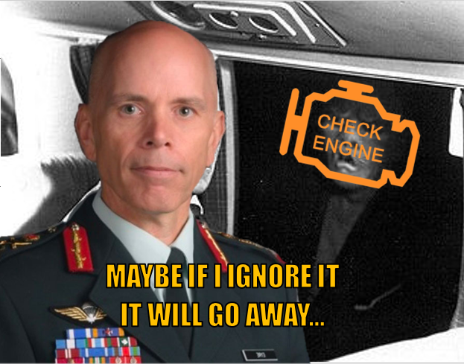
Have you ever been blessed by the Check Engine Light (CEL) on your car? Count yourself lucky if you haven’t, but most of us have had to greet it at some point. It indicates that a computer within the car’s operational systems has detected something wrong, and is letting you know. Of course, many cars also have other, separate warning lights for things like brakes, airbags, and electrical problems, but the CEL is the most common one to appear, and often shows up due to things like vacuum leaks, broken oxygen sensors, and exhaust gas recirculation valves that aren’t valving anymore. If one blesses you at any point, the correct thing is to check the cause(s), either using a hand-held scanner, or using dedicated computer software if you can get it. This will tell you what specific error is causing it to illuminate. Of course, this pragmatic attitude is easy for people with a mechanical inclination, who aren’t afraid of cars, and have an understanding of their workings. If you aren’t one of those people, the CEL can be quite frightening, as it might imply spending money on repairs. But more frightening than the CEL itself is the root cause. If you leave the light alone, you can assume something is wrong but ignore the severity, whereas if you check the actual cause, you remove all doubts, and will be presented with the problem however severe it is. You could think of it like Schrodinger’s engine; The problem is both inconsequential and catastrophic until you check; If it’s a German car, probably both.
I think that the CAF has had its CEL on for a while, decades in fact. A few of the drivers have checked the CEL in the past, but discovered that it was just an oxygen sensor, not the sort of thing that will kill the car in any short amount of time. They subsequently pretended to do something without actually crawling underneath to deal with it, as that would require work. Or maybe they didn’t have the tools to do it at the time. Over time, the CEL remained on, but additional problem codes started accumulating. The leaders, through fear, apathy, or otherwise, continued driving since the car was still moving under its own power. A few brave souls did actually open the hood of the car a few times, but they were overwhelmed by the myriad of hoses and wires and quickly got back in the cab and hoped for the best, despite the fact that the engine was now making strange noises at idle.
In Autumn of 2021, the CDS drove the car headfirst into a road sign reading Exit 69: Vaccine Mandate Boulevard. We don’t know if he was drunk or if his boss, who was in the car at the time, told him to do it or face consequences. After duct taping the front end together, he lumbered the car back to National Defence Headquarters to inspect the damage, thoroughly surprised that the car was even still moving. Upon arriving, every light on the dash was on, and something was dripping (don’t tell the environmentalists!) from near the engine. The CDS decided that instead of pulling codes and fixing the accumulation of damage, he would instead buy new rims and a new stereo to make himself, his boss, and the taxpayers feel better about the car, while also adding a rainbow flag sticker on the back.
Since the CDS doesn’t want to plug in a scanner and check things out, maybe we can take a quick look instead. First, let’s scan the car for how many deployable personnel there are:

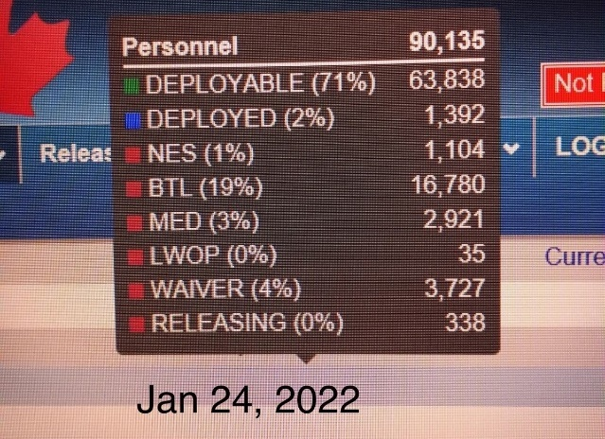
I see. Not bad. We’re at 71% deployable, with deployable meaning ready to go out the door tomorrow and do military stuff. Maybe, if we’re lucky, we’ll be able to defend against the Chinese for 3 hours instead of 1. There’s a problem though: According to the source, the CAF is already about 10,000 people short as of January 2022. That’s about a 10% shortfall, not insignificant at all. As that number grows, the effects of it will also increase geometrically, burdening those who stay in and forcing reduction in capability.

How about we now inspect the damage from driving into that road sign?
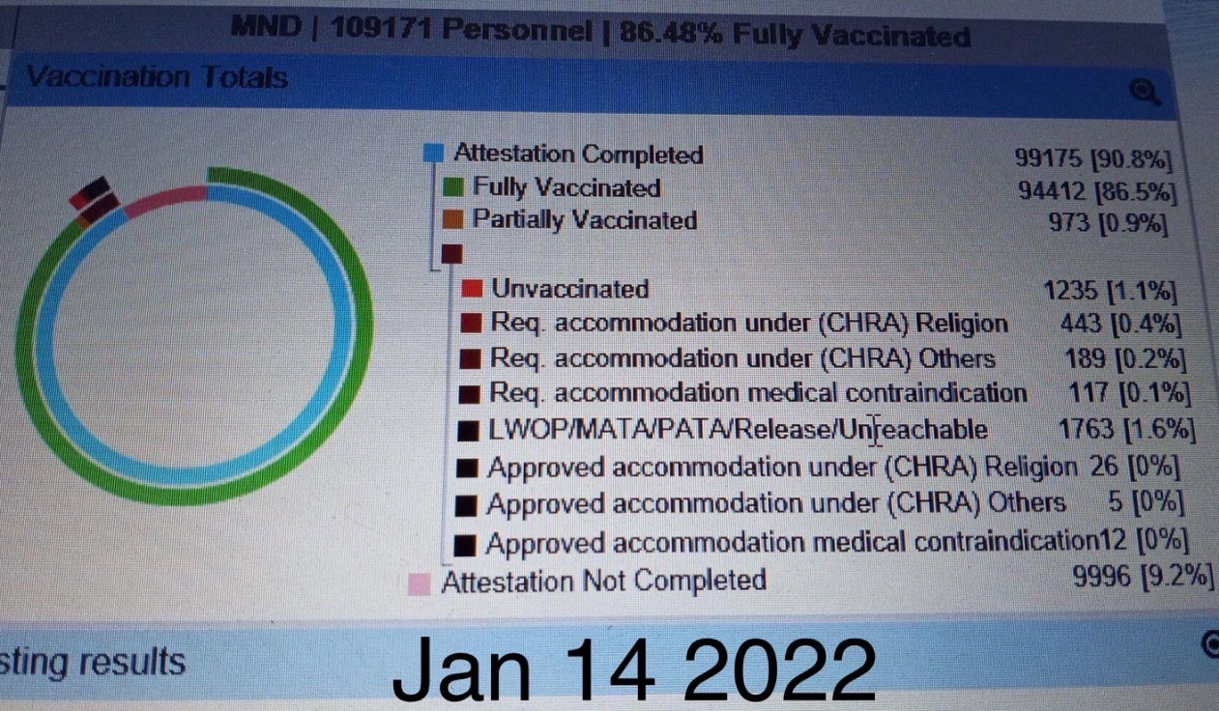
Oof, that’s not good! For those watching at home, in addition to the ~10% already missing, we have about another 10% who have either refused the jabs, or refused to state their jab status. Fortunately, the CAF can just remove the mandate and they can all hug and forget it ever happened, right? HA! I highly doubt that. Of the variety of CAF members that I spoke to who have declined the vaccine, all of them are adamant about leaving the CAF, as they still feel the knife wound in their back, and I hardly think they are a fringe case. Good luck ever convincing them to return. If my math is correct, we are on track for the CAF to be at 80% manning or less in the very near future, regardless of any decisions or cancellations on the mandatory jab policy. I want you to pay attention as well to some specific lines in this image. Note the line for requesting accommodation under religion (CHRA) and compare it to the lower line for how many of those accommodations were actually granted. 443 CAF members requested exemption due to their faith, but only 26 of those were granted as of January. The only possible reason for such a delay is political interference and meddling in the process, as an honest approach would yield those accommodations almost immediately. Of course, an honest approach would not have allowed this situation to begin with, nor would it have warranted me writing this diatribe at all.
I don’t know how this could possibly be fixed, to be completely frank. Even if I joined the CAF tomorrow and became CDS the day after, I am sure that I couldn’t do more than a slight polish on the turd, so I guess I need to cut the existing CDS and his recent predecessors some slack. Maybe they see that it’s pointless, so they’re crashing the plane with no survivors like someone who failed their mission in Grand Theft Auto, just to see what would happen. But unlike a plane in a game, this one has real troops in it, insofar as they consider filthy plebs to be human.

As a confirmation of what we now know to be true, word on the street is that over 9000 (no pun intended) have been released thus far (July) in 2022 alone. That is absolutely insane, yet totally predictable. Who even knows how many of these are jab related or due to other reasons? If I lived in viewing distance of NDHQ, I think it would be a good time to just crack open a cold one and enjoy the chaos.

All Good Things Come To An End
Everything under heaven is in utter chaos; the situation is excellent.
-Chairman Mao
So, where do we go from here? Nowhere, in all likelihood. We are where we will be in ten years, that being a state of decay. The CAF will continue to exist permanently in a state of managed decline, while impotently attempting to solve its problems by using them recursively as solutions, as though it were an alcoholic trying to drink itself sober. The acknowledgement of any of the root causes (with the CAF or country at large) is or will be imminently illegal to say, as the country rapidly becomes an absolute police state but with rainbow stickers and emojis (see England for a glimpse of the future). Though the CAF may see itself investing in new equipment, it will be absolutely pointless as our gravest enemies are the ones writing our orders, not a bunch of Russian lads or inexperienced Chinese generals. Any future kinetic conflicts the CAF finds itself in will almost certainly be elective, and located in irrelevant holes that the world forgot about for a reason, with no bearing on our collapsing country whatsoever. The realization of this truth, even subconsciously, will ensure that the CAF recruits and retains primarily the self-interested, who will stay only as long as they get what they want out of it. In other words, a green welfare. As these individuals infest the CoC, they themselves will perpetuate apathy by disregarding their peers and subordinates in the name of what is easy for them. Ultimately, the regime doesn’t need the CAF anymore in its traditional capacity, at least not outside of their capacity to virtue signal; The militarized police are likely capable of fighting their true enemies if need be, those being any citizens who question their forced march towards the end of a way of life.
The CAF won’t cease to be, however, as such a move would be political suicide for any party which tries it. What, then, will it be primarily used for? I’d imagine that domestic problems will be the primary focus of the CAF, mainly natural disasters. The CAF is already leveraged to assist with things like flooding and forest fires, though primarily for manual labour like moving sandbags and digging holes, and its role in these oft-yearly events will likely expand as provincial governments have come to expect the CAF to fill in the holes in their own disaster contingencies. In Canada’s slow quick descent to tyranny, we can plausibly expect the CAF to also fill the role of enforcers or presence patrols to project the authority of the regime in cases where the people have the audacity to publicly question the deletion of their liberties, à la trucker convoy, though this will likely be only in a limited fashion and only as a backup in case the cops get tired or go on vacation. Outside of these potential use cases, the CAF will send its members about to represent the values of inclusion and diversity by doing nothing, while the regime sends more cash to their friends by purchasing more unnecessary equipment from their seedy companies. At the end of the day, it will be another toy for the regime to show to everyone; a decrepit tractor become lawn ornament. The show is over, hopefully you had fun.

